**The Walking *Moai* Hypothesis (Easter Island): Archaeological Evidence, Experimental Validation, and Response to Critics**

1Department of Anthropology, Binghamton University, 4400 Vestal Parkway, Binghamton, NY 13902, [*clipo@binghamton.edu*](mailto:clipo@binghamton.edu)*,* [*https://orcid.org/0000-0003-4391-3590*](https://orcid.org/0000-0003-4391-3590)

2School of Anthropology, P.O. Box 210030, Haury 210, University of Arizona, Tucson, Arizona 85721; [tlhunt@arizona.edu](mailto:tlhunt@arizona.edu), <https://orcid.org/0009-0008-6257-8533>

**Abstract**

The transport of Rapa Nui’s (Easter Island) monumental *moai* statues has been debated for over a century. Based on a systematic analysis of 962 *moai*, with a focus on 62 road statues, combined with 3D modeling and experimental trials, we demonstrate that these multi-ton megaliths were designed to be transported vertically in a controlled "walking" motion facilitated by their carved shapes. Our evidence includes distinctive morphological features of road *moai* (wide, D-shaped bases and forward lean), archaeological road characteristics (4.5m wide, concave cross-sections), non-random breakage patterns, and the first successful experiment using a replica weighing 4.35 metric tons. Despite empirical support, several scholars have challenged the walking hypothesis. This paper systematically addresses critiques that demonstrate how objections fail to account for the comprehensive archaeological evidence supporting vertical transport.

# **1. Introduction: Twelve Years of Walking *Moai***

As Karl Popper once observed [(1962, p. 50)](https://www.zotero.org/google-docs/?jpZFaB), “science must begin with myths, and with the criticism of myths.” Few archaeological cases have resulted in the creation of myths as significant as the massive *moai* of Rapa Nui and the methods used to transport them. In 2013, we published experimental evidence demonstrating that Rapa Nui's massive stone statues "walked" from their quarry to ceremonial platforms across the island, challenging the myth of horizontal transport that had dominated archaeological discourse for decades [(Lipo et al., 2013)](https://www.zotero.org/google-docs/?ysLV8X). The research captured global imagination, gracing the cover of *National Geographic* magazine and generating millions of views as audiences worldwide watched our video demonstrations of a 4.35 metric ton *moai* replica taking its first steps.

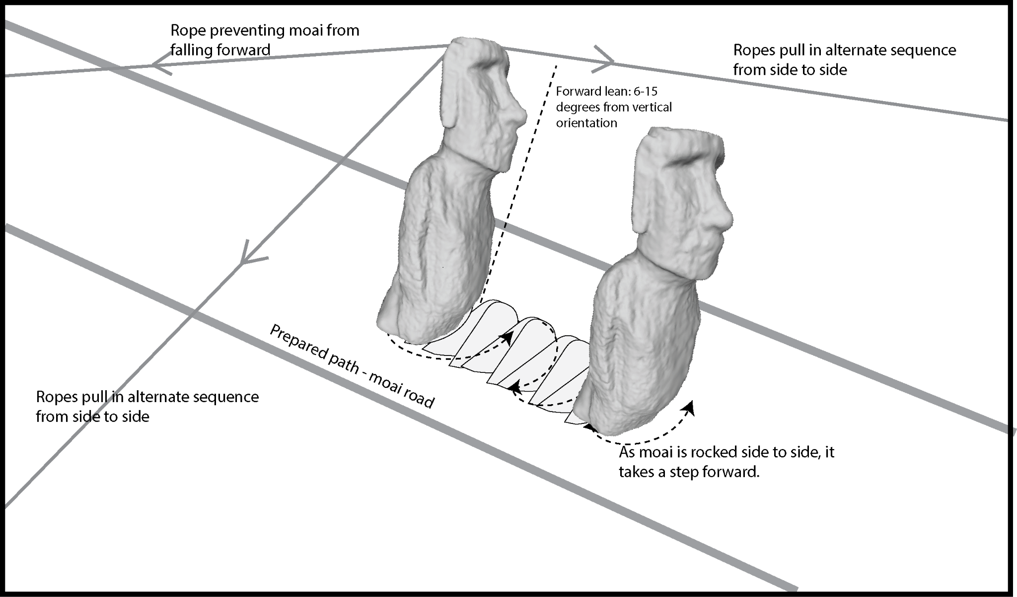

***Figure 1. Schematic representation of the moai transport method using coordinated rope pulling.*** *The diagram illustrates the "walking" technique whereby moai were moved along prepared roads through alternating lateral rope pulls while maintaining a forward lean of 6-15 degrees from vertical. A restraining rope prevents forward toppling as side ropes create a controlled rocking motion that advances the statue with each oscillation. The movement of the moai follows a characteristic zig-zag path created by this side-to-side stepping motion.*

Notably, the Native Rapanui community has for centuries enthusiastically embraced this understanding of their ancestors' remarkable engineering achievements. Indeed, a widely known *moai* walking song recounts an early ancestor, *Tu`u Ko Iho*, who, as the lyrics tell, knew how to make the statues walk. Like traditional working songs worldwide, it shares striking musical features that serve practical functions in coordinating labor. Work songs feature a pronounced, steady rhythm with a tempo and beat tailored to match the pace of repetitive tasks, thereby synchronizing workers’ movements, such as pulling lateral ropes. Today’s *moai* walking song reflects the persistence of ancient cultural memory. M*oai* walking was recently celebrated with a performance of the song during Tapati Rapa Nui, the island's premier cultural festival, where reenactments of the transport of vertical statues were a highlight of the celebrations. Such *moai* walking reenactments are regularly celebrated in cultural performances on the island today. The islanders have reclaimed their narrative of ingenuity rather than one of failure with ecological collapse (Diamond 2005). The integration of walking *moai* into cultural performances reflects a dedication to preserving and celebrating authentic Rapa Nui traditions. It represents the community's recognition that this method aligns with their oral histories and cultural knowledge.

Yet, despite widespread acceptance and the convergence of archaeological, experimental, and ethnographic evidence supporting vertical transport, more than a decade later, some scholars continue to reject the walking hypothesis without offering falsifiable alternatives or addressing the comprehensive evidence we presented. This situation exemplifies Kuhn’s insight into scientific resistance to paradigm shifts. The walking hypothesis challenges not only transport mechanics but the broader narrative of Rapa Nui as an ecological cautionary tale. As Kuhn [(1962)](https://www.zotero.org/google-docs/?Pxnup5) noted, “normal science” often forces new evidence into old frameworks, while Popper [(1962)](https://www.zotero.org/google-docs/?B7IirU) emphasized that science advances by testing and rejecting falsified theories. The issue is not whether scholars *prefer* horizontal or vertical transport, but which hypothesis better explains the archaeological evidence and withstands experimental scrutiny. Rather than confirming a narrative of environmental collapse driven by statue transport using thousands of trees for wooden rollers, experimental archaeology points to sustainable practices: the statues were moved upright using simple physics and teamwork—a resourceful solution, not an environmentally destructive one.

In this review, we pursue two goals. First, we consolidate the theoretical and empirical foundations supporting *moai* walking, drawing on twelve years of additional research, refined experiments, and new archaeological discoveries. Second, we systematically address each published critique, demonstrating how these objections fail to meet the basic criterion of scientific discourse: falsifiability. Our goal is not merely to defend our hypothesis but to follow Laplace's principle [(1902, p. 17)](https://www.zotero.org/google-docs/?YpCmJH), that “the weight of evidence for an extraordinary claim must be proportioned to its strangeness.” In this case, the extraordinary evidence supports the extraordinary claim that multi-ton statues walked. In our research, we subjected the walking hypothesis to experimental tests, creating conditions where failure was possible. Indeed, we failed to initiate movement and dropped our replica statue multiple times before successfully transporting it. Meanwhile, critics offer no comparable experimental validation, no falsifiable predictions, and no comprehensive explanation for the archaeological evidence.

The critics we address—Bahn, Flenley, Van Tilburg, Diamond, Velasco, Richards, Cauwe, and De Dapper—represent established voices in Pacific archaeology. Their objections deserve serious consideration, yet as we demonstrate, none provide falsifiable alternatives or address the convergence of evidence supporting vertical transport. Their critiques fail Popper's fundamental test: they cannot specify what evidence would convince them their positions are wrong while simultaneously ignoring evidence that contradicts their claims.

Here, we offer both a vindication of experimental archaeology and a case study of scientific resistance to paradigm change. We begin by establishing the empirical foundation for walking transport, drawing on an analysis of nearly 1,000 *moai* with a focus on 62 statues that were abandoned during transport. We then address each published critique, applying Popper's criterion of falsifiability to each. The *moai* walked—the evidence is carved in stone, validated through experiments, and celebrated in contemporary Rapa Nui culture. The question is why some scholars, despite claiming allegiance to scientific principles, still refuse to accept this model for the transportation of *moai*.

## 1.1 Archaeological Evidence

Our comprehensive study analyzed 962 *moai* across the island, representing the most extensive systematic documentation of the Rapa Nui statuary to date. This database, compiled through field surveys and photogrammetric documentation, includes statues from multiple contexts, such as quarries, roads, and ceremonial platforms [(Hochstetter et al., 2011)](https://www.zotero.org/google-docs/?CO4lfJ). Of particular significance are 62 statues documented along ancient transport roads, abandoned where they fell at various points of their journey from the Rano Raraku quarry. These road *moai*, preserved in their transport configuration, provide crucial evidence for understanding prehistoric moving techniques [(Lipo et al., 2013; Lipo and Hunt, 2005)](https://www.zotero.org/google-docs/?4mKfrh).

The road *moai* were identified through several criteria establishing their in-transit status. Each statue lies adjacent to road alignments that radiate from Rano Raraku, oriented in directions consistent with movement away from the quarry. Their distribution along roads, combined with evidence of transport failure such as breakage patterns, confirms that these represent abandoned transport attempts rather than deliberate installations.

Analysis of these road *moai* reveals three distinctive morphological characteristics that differentiate them from statues successfully erected on ceremonial platforms (*ahu*), pointing to purposeful engineering for transport (Figure 2). First, road *moai* possess significantly wider bases relative to shoulder width compared to *ahu moai*. Our quantitative morphometric analysis documents this relationship precisely: road statues exhibit a shoulder-to-base width ratio approaching 1.0, meaning the base width nearly equals the shoulder width. This arrangement creates a broadly stable foundation with the mass distributed low on the statue. In contrast, platform statues show ratios consistently exceeding 1.0, with shoulders wider than bases, creating a more top-heavy configuration. This modification occurred after transport, when carvers reduced the base width to achieve the aesthetic proportions desired for display, while also enabling stable upright positioning on level *ahu* surfaces. The wider bases of road *moai* serve a critical functional purpose: they lower the center of mass and provide the lateral stability essential for the side-to-side rocking motion of walking transport (Figure 3). The broad base acts like the rounded bottom of a bowling pin, allowing the statue to rock significantly without toppling sideways.

Second, road *moai* exhibit a pronounced and consistent forward lean, typically ranging from 6° to 15° from vertical. This forward lean positions the center of mass close to or even slightly beyond the front edge of the base, a configuration that renders independent standing impossible without support (Figures 4 and 5). Three-dimensional modeling confirms this forward displacement of mass is not incidental but carefully engineered. When tilted laterally during transport, this forward lean causes the statue to fall forward in a controlled manner, with the rounded front edge of the base acting as a pivot point for forward rotation. Each lateral rocking motion thus produces a forward "step" as the statue rolls along its front edge. Platform *moai*, once they reached their destinations, were substantially modified through base reshaping to eliminate this lean. Carvers removed material from the front of the base and added support at the rear, shifting the center of mass back over the base center to achieve stable upright positioning. Tailings of Rano Raraku volcanic tuff from *moai* and found in *ahu* platforms provide the physical signature of this step in the process (S. Rapu, personal communication, 2011). The transformation of *moai* form from transport-enabled to platform-ready was critical, yet this distinction had gone unnoticed among most archaeologists..

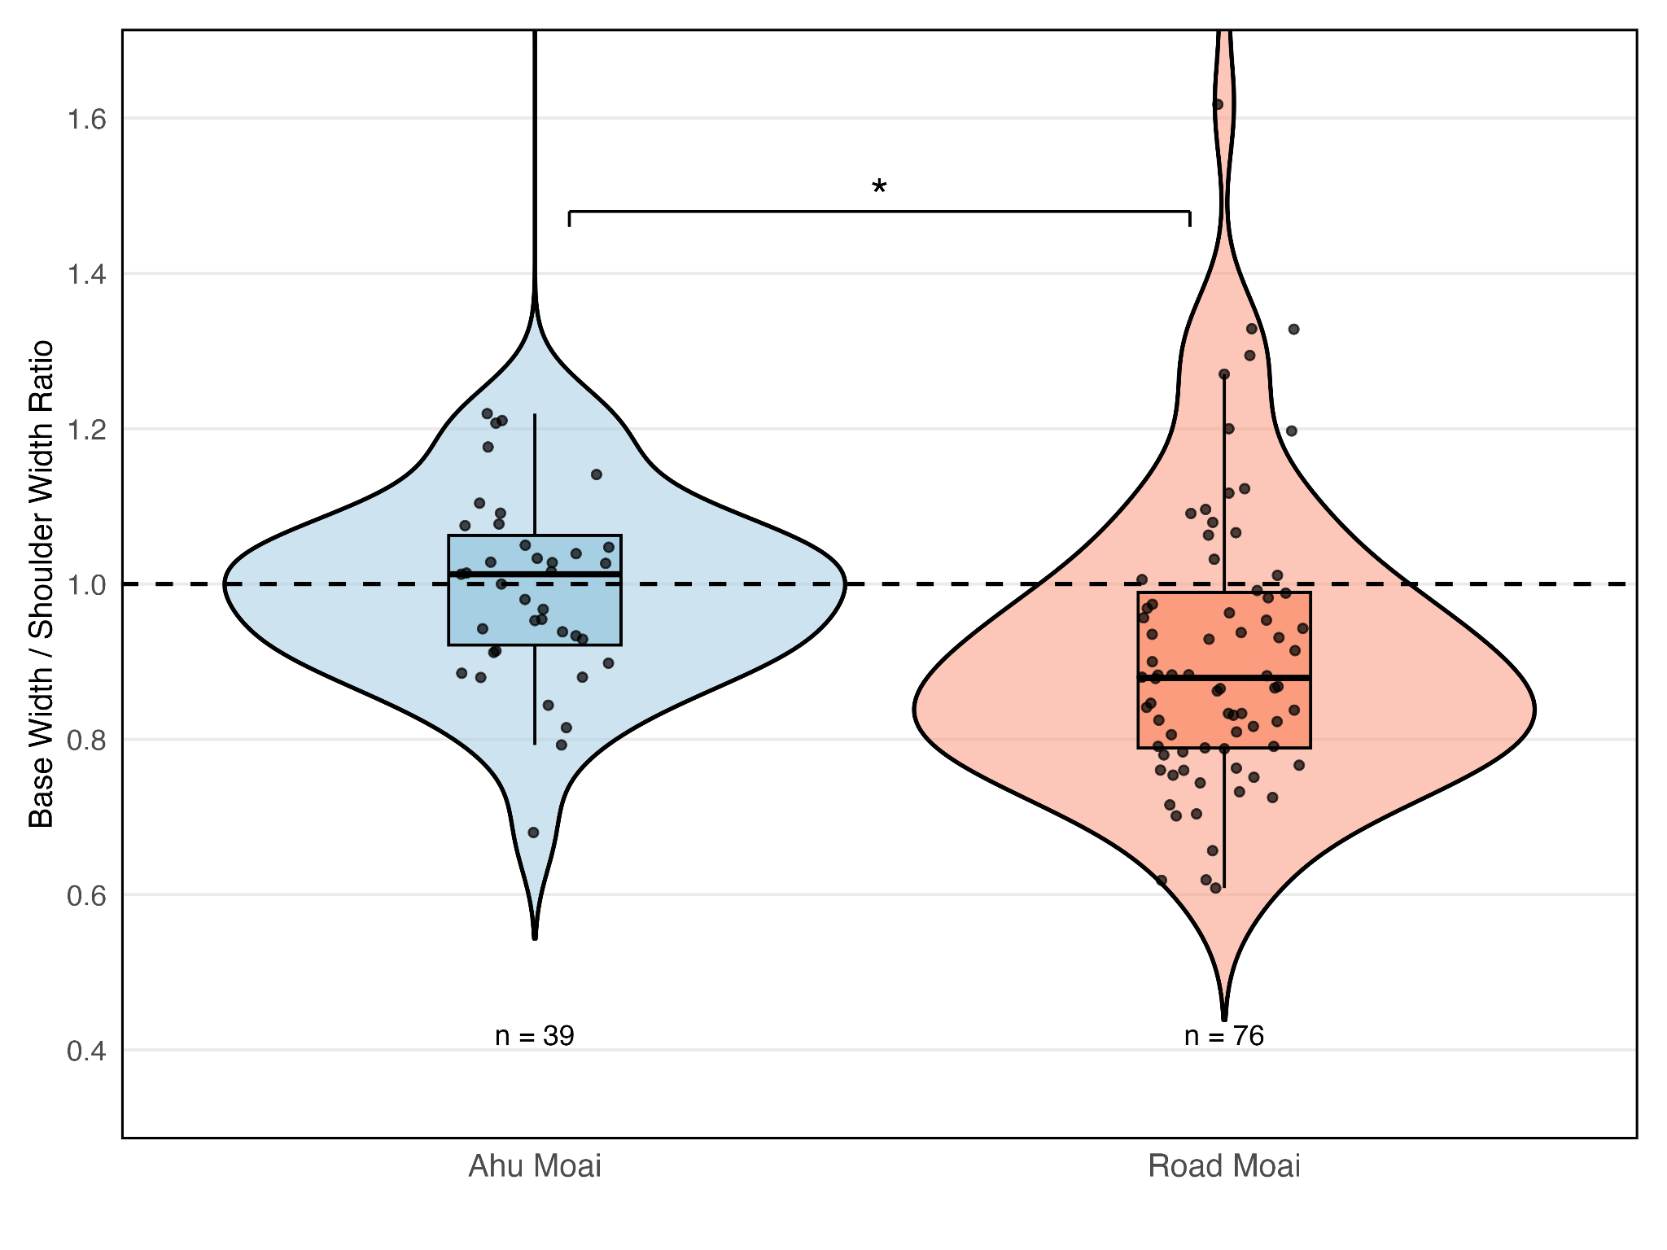

***Figure 2. Comparison of the ratio of base width to shoulder width for ahu moai (left) and road moai (right).*** *Using measurement data of moai from Van Tilburg* [*(1986)*](https://www.zotero.org/google-docs/?w6amfW)*, the figures show that the two types of moai have statistically distinctive ratios (Welch's t-test: t = -2.248, df = 96.4, p = 2.69e-02).*

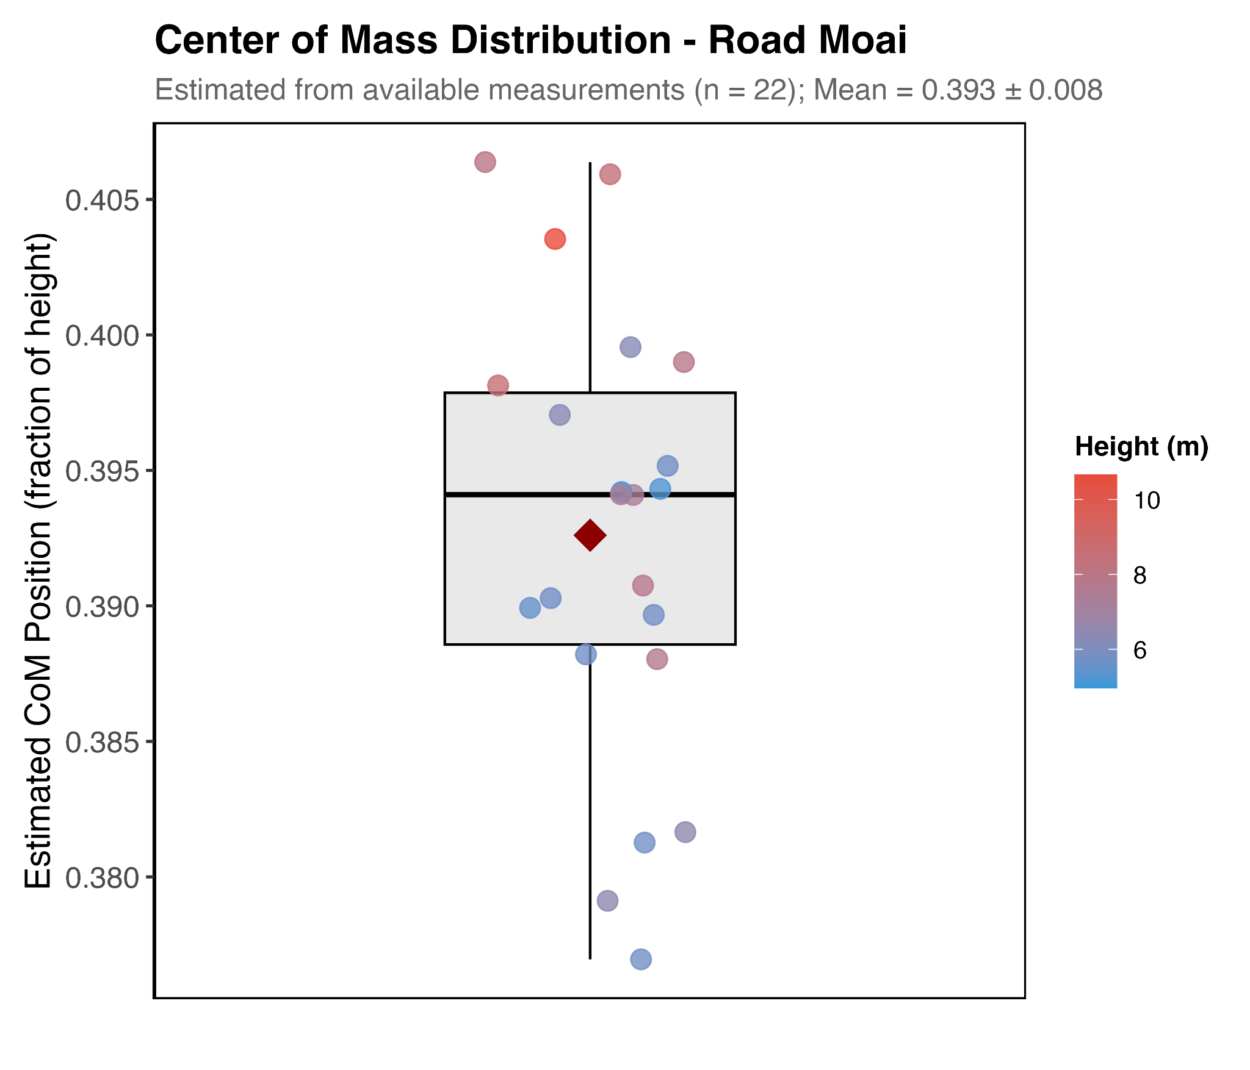

***Figure 3. Center of Mass Calculation (CoM) for Road Moai (n=22).*** *CoM positions were estimated from Van Tilburg* [*(1986)*](https://www.zotero.org/google-docs/?OLRfKc) *data using a volumetric sectional analysis based on available morphometric measurements (total height and base width, with shoulder width when available). The analysis divided each moai into four anatomical sections (base: 20%, belly: 35%, chest: 25%, head: 20%) with assumed elliptical cross-sections and depth estimated at 50% of the width for body sections and 60% for the head section. Individual moai are represented as points colored by height, with a box plot indicating the median, quartiles, and range. The mean CoM position (red diamond) of 0.395 ± 0.013 (fraction of total height from base) indicates all road moai have centers of mass well below the midpoint (0.5), consistent with the stability requirements for oscillatory walking transport. Due to limited measurement data and necessary geometric assumptions, actual CoM positions may vary by ±5-10% from these estimates. More precise determination would require three-dimensional scanning or additional morphometric measurements, including depth profiles and intermediate width measurements along the moai body.*

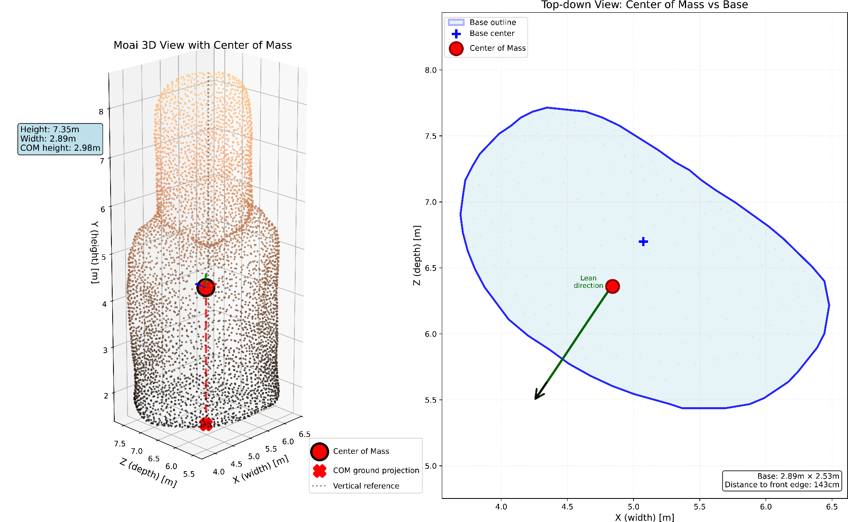

***Figure 4. Center of mass analysis of a Rapa Nui moai 3D model.*** *(Left) Three-dimensional visualization of moai 12-220-01 showing the moai mesh (n = 5,150 vertices) colored by height, with the center of mass indicated by a red sphere located at 40.6% of the statue's total height (2.98 m above base in a 7.35 m tall moai). The vertical dashed line shows the projection of the center of mass to the base plane, and the dotted vertical line indicates a true vertical reference from the base center. Text annotations indicate a forward lean angle of 6.5° and the dimensions of the moai (height: 7.35 m, width: 2.89 m). (Right) Top-down view showing the D-shaped base outline (blue) derived from a horizontal cross-section 10 cm above the base. The center of mass (red circle) is projected within the base footprint, positioned 23.2 cm to the left and 34.0 cm backward from the geometric center of the base (blue cross). A solid black arrow connects the base center to the center of mass projection, while a green arrow indicates the lean direction. The base measures 2.64 m × 2.10 m, with the center of mass located 139 cm behind the front edge. All axes display scaled coordinates in meters, preserving the actual dimensions of the moai.*

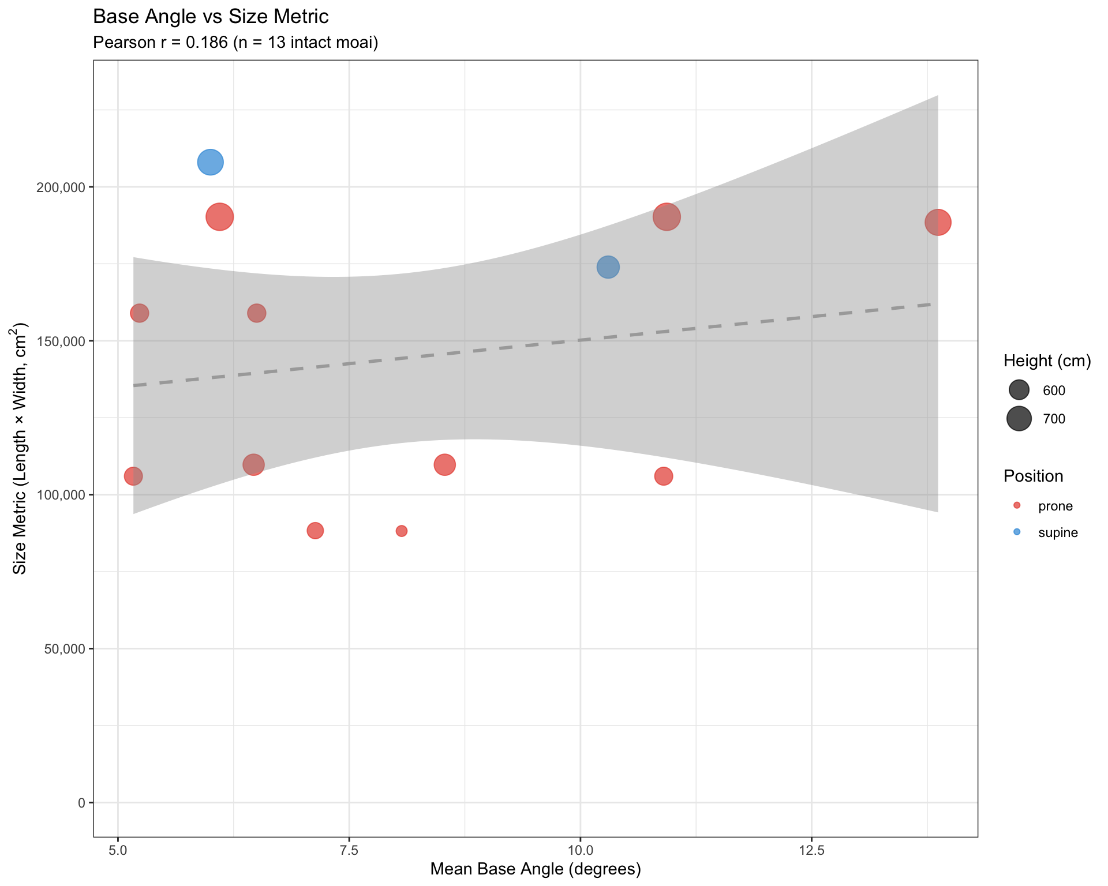

***Figure 5. Relationship between moai base angle and size metric (total length × base width) for intact road moai (n = 13).*** *Using data from Schumacher* [(2013)](https://www.zotero.org/google-docs/?dsWQRu) *and additional measurements of moai basal angles, the figure shows individual moai, with point size proportional to* moai *height (cm) and color indicating final resting position (red = prone/face down, blue = supine/face up). The dashed line represents the linear regression fit, along with its 95% confidence interval (shaded area). A weak positive correlation (Pearson r = 0.186) was observed between the base angle and size metric, suggesting that the base angle construction was relatively standardized across the size range of the transported moai. The narrow range of base angles (5-14°) despite substantial variation in moai size (approximately 50,000-200,000 cm²) supports the hypothesis that a specific angle range was optimal for the walking transport method. Data represent only intact moai found along the ancient roads, excluding fragmented specimens.*

Third, road *moai* uniformly lack carved eye sockets, a definitive indicator of their incomplete ceremonial status. In the Rapa Nui tradition, the eyes (*mata*) were not merely decorative but spiritually transformative elements that activated the *mana* (spiritual power) of the ancestors represented by the *moai*. Ethnographic accounts and archaeological evidence confirm that eyes were carved only as a final step after the statue’s successful erection on the platform. These sockets were designed to hold white coral eyes with obsidian or red scoria pupils, creating a striking gaze that overlooked ceremonial spaces. The insertion of eyes, often accompanied by the placement of red scoria hats (*pukao*) on larger statues, marked the transformation from carved stone to living ancestor denoted by the phrase “*oringa ora o te tupuna*” in the Rapanui language. The complete absence of eye sockets on all 62 documented road *moai* confirms these statues never reached the ritual completion stage. This pattern holds even for unbroken road *moai* that lay near *ahu* platforms, indicating that proximity to a ceremonial site was insufficient—only successful erection triggered the final transformation.

The wide bases with a low center of mass and engineered forward lean worked in tandem to enable vertical transport. The absence of eye sockets signaled the *moai* was not yet complete. The morphology is not accidental but rather represents sophisticated engineering adapted to the available technology and landscape challenges. The consistency of these features across road *moai*, regardless of size or location, indicates standardized production methods optimized for walking transport.

## 1.2 Road Infrastructure

Archaeological investigations of *moai* roads reveal a sophisticated transportation infrastructure extending over 25 km from the Rano Raraku quarry [(Lipo and Hunt, 2005)](https://www.zotero.org/google-docs/?ytNhvV). These engineered pathways, first documented by Katherine Routledge in 1919, provide critical evidence for understanding the mechanics of transport [(Routledge, 1919)](https://www.zotero.org/google-docs/?lh7gmq). The roads maintain consistent dimensions across varied terrain, averaging approximately 4.5 meters in width—sufficient for maneuvering multi-ton statues.

Significantly, the roads exhibit distinctive concave cross-sections. Excavations reveal that these concavities match the curved arc of the *moai* base edges, suggesting purposeful engineering to guide the statues during transport [(Love 2001)](https://www.zotero.org/google-docs/?284EPF). When road profiles are compared with *moai* base configurations, the correspondence indicates that the concave shape would help constrain lateral movement during the rocking motion of walking transport.

Gradient analysis along two extensively studied south coast road sections documents the extraordinary topographic challenges overcome by prehistoric engineers. As Figure 6 shows, the maximum slopes traversed are around 20-25% (18-22 degrees) for short sections, though the average is 4% (3.6 degrees). These gradients would present significant challenges for horizontal transport methods. Experimental attempts to move horizontal loads on comparable slopes would require substantially increased force and risk uncontrolled sliding. In contrast, our walking experiments demonstrated that vertical statues can navigate such slopes through controlled stepping.

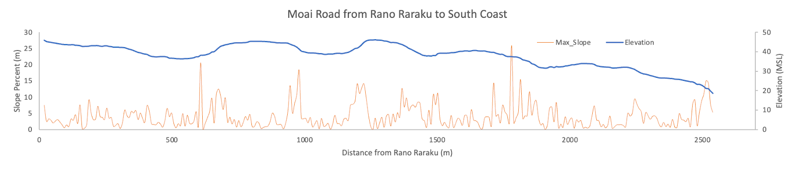

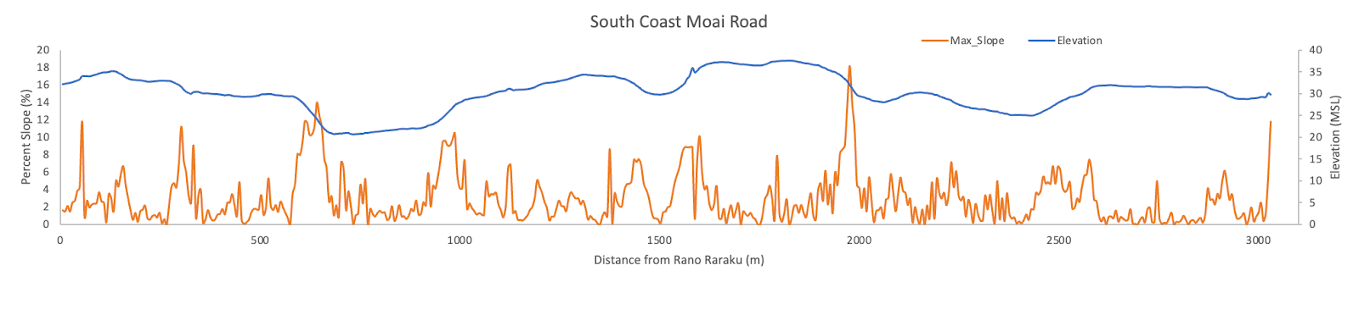

***Figure 6. Variability in slopes for the paths of moai roads.*** *This figure shows the elevation change for two well-preserved sections of moai roads. The top figure shows a section of the road that leads from the quarry at Rano Raraku to a location along the south coast. The lower figure shows a moai road path that extends east-west along the south coast. The two road sections show similar elevation changes and slope patterns. We calculated slopes using 8-meter increments to represent the challenges the Rapanui people would have faced while walking their moai along the road. The maximum slopes traversed are around 20-25% (18-22 degrees) for short sections, though the average is 4% (3.6 degrees)*.

The absence of modifications necessary for roller or sledge systems across the documented road network, despite preservation conditions that would retain such evidence, argues against horizontal transport. The roads appear expressly designed for vertical statue movement, with their width, concave profile, and capacity to handle steep gradients–supporting the walking hypothesis.

## 1.3 Physical Evidence from Failed Transport

The 62 documented road *moai* represent direct evidence of transport failure, preserving information about movement methods. Our analysis reveals patterns consistent with vertical transport across multiple lines of evidence. Breakage pattern analysis shows that 37% of road *moai* exhibit breaks consistent with falling from a vertical position. These breaks typically occur at geological weaknesses where bedding planes intersect carved features, producing horizontal fractures through necks or torsos rather than the vertical splitting expected from lateral impacts from horizontal dragging.

Diagnostic evidence comes from patterned base damage. Analysis reveals that 70% of road *moai* bases exhibit lateral edge fractures appearing as broad, shallow concave scars where pressure flakes detached. These fractures concentrate on lateral edges, precisely where maximum stress would occur during side-to-side rocking motion. The absence of longitudinal scraping or grinding marks, which are typically expected from horizontal dragging, further supports the notion of vertical transport.

Statistical analysis of *moai* positions relative to road topography provides independent confirmation. The positions of fallen statues are statistically non-random (*p* < 0.05) with respect to slope: the majority are found face-down when roads slope downhill and frequently on their backs when going uphill. This pattern aligns with expectations for forward-walking statues, where downhill falls result in forward positions, while uphill falls cause backward positions as the statues tip away from the direction of travel.

***Table 1: Position of moai relative to road slope for 51 of the road moai*** [***(after Hunt and Lipo, 2011, p. 203)***](https://www.zotero.org/google-docs/?fCOhkz)***.***

|  |  | **Direction of Slope Relative to *Moai*** | | | |
| --- | --- | --- | --- | --- | --- |
|  |  | *Downhill* | *Flat* | *Uphill* | ***Total*** |
| ***Moai* Position** | *Face Down* | 17 | 3 | 11 | **31** |
| *Face Up* | 3 | 0 | 16 | **19** |
| *Lateral* | 0 | 0 | 1 | **1** |
| ***Total*** | **20** | **3** | **28** | **51** |

Two examples along the South Coast Road preserve evidence of ancient attempts at re-erection. At these locations, unbroken *moai* protrude, partially buried with their bases below ground (Figure 7). A fallen statue could be brought back to a vertical position by excavating under the lower portion, thus enabling an adequate angle to right it with ropes. These re-erection attempts demonstrate that statues were transported upright; horizontal statues would require entirely different recovery methods.

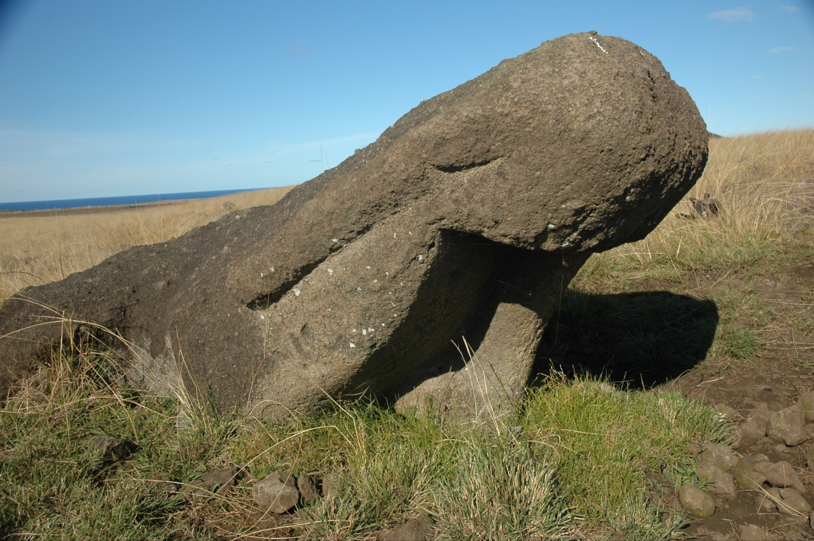

***Figure 7. Example of a road moai (south coast) that fell and was abandoned after an attempt to re-erect it by excavating under its base, leaving it partially buried at an angle.***

## 1.4 Three-Dimensional Modeling and Experimental Validation

Using photogrammetric techniques, we created precise 3D models of road *moai*, revealing crucial engineering features. The models confirm that road *moai* exhibit a pronounced forward lean, often exceeding 10°, which positions the center of mass close to or slightly beyond the front edge of the base. This engineered instability prevents the statue from standing independently but facilitates forward motion when it is tilted from side to side.

For experimental validation, we used structure-from-motion software to produce a precisely scaled replica based on road *moai* 12-220-01, located 3.54 km from Rano Raraku along the south coast *moai* road. The original statue stands 7.35 m tall and 2.83 m wide. Our concrete replica, scaled for practical experimentation, weighed 4.35 metric tons and retained the same proportions and mass distribution as the original. The concrete also included expanded polystyrene additives to achieve the specific gravity of the Rano Raraku tuff.

Experimental trials yielded quantitative validation of the walking hypothesis (Figures 8 and 9). With a minimum crew of 18 individuals, four on each lateral rope and ten on the rear rope, we successfully achieved walking motion. The statue could be tilted laterally as much as 26° from vertical before the risk of toppling sideways, providing substantial clearance for the stepping motion. Through coordinated rope work in one continuous effort, we achieved sustained forward movement of 100 meters in just 40 minutes.

The walking mechanism operates through pendulum dynamics. Once the rocking motion is initiated, the statue’s oscillation requires minimal energy input to maintain, with rope handlers primarily providing guidance rather than motive force. The forward lean causes each lateral tilt to produce forward movement as the statue rolls across its curved front edge.

Our experiments revealed that movement in a vertical walking motion is not only possible but remarkably efficient. Unlike horizontal dragging methods, which require a constant high-force application and risk damage to the statue, the walking method conserves energy through pendulum motion. It minimizes friction between the base and the ground. The rapid transport rate achieved—100 meters in 40 minutes—suggests statues could have been moved several kilometers in a matter of weeks, requiring only modest-sized work crews rather than the massive labor forces assumed by horizontal transport hypotheses.

The scaling properties of the walking method indicate that larger statues would not be proportionally more difficult to transport, as increased height provides greater leverage for rope teams. This explains how the ancient Rapanui successfully moved statues that were over 10 meters tall, weighing approximately 74 metric tons, over distances exceeding 5 km. These achievements would be extraordinarily difficult using horizontal methods, but are perfectly congruent with the walking technique we demonstrated.​​​​​​​​​​​​​​​​

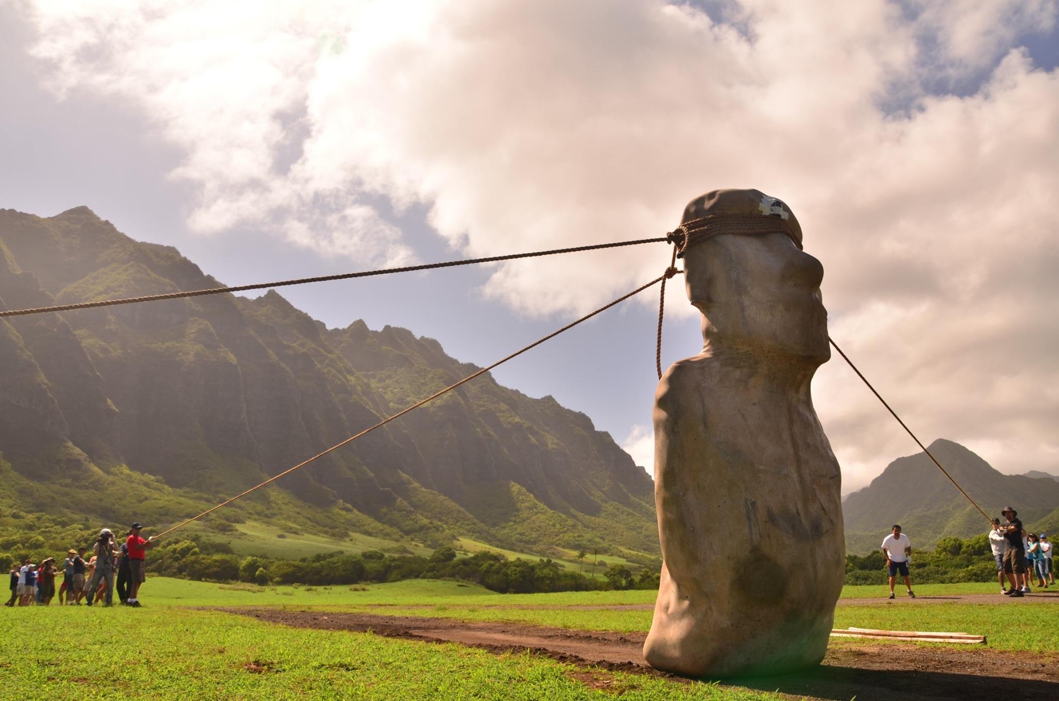

***Figure 8. Our 2012 experimental moai transport demonstration, showing the rope configuration for the 4.35-ton replica moai using the "walking" method.*** *One rope is attached to each side of the replica to generate the alternating rocking motion. A third rope, secured to the back of the statue, serves a dual function: preventing forward toppling during the rocking sequence and allowing operators to pull the moai backward for positional adjustments. This three-rope system enables the controlled manipulation of the statue's center of gravity, allowing for forward locomotion through coordinated lateral oscillations.*

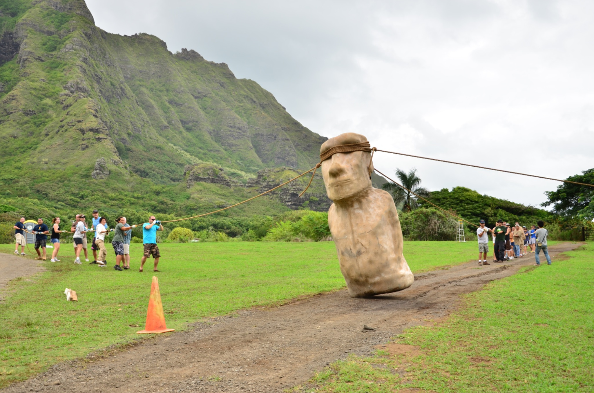

***Figure 9. Moai walking in progress.*** *The replica's forward-leaning posture is crucial to the method: as participants rock the statue from side to side using ropes, the forward center of gravity converts each lateral movement into a step-like advance along the path.*

## 1.5. Workforce Requirements for Moai Transport

To understand the human resources required for *moai* transport, we developed a physics-based model incorporating mass estimation, force calculations, and workforce requirements. Our approach builds on our experimental archaeology and quantitative analysis of labor requirements across the full range of *moai* sizes.

We calculated the mass of *moai* using dimensional analysis and material properties. We estimated volume using the formula

*Eq. 1. $V=h×\underline{w}×\underline{d}×φ$*

where *h* is height, *w̄* is average width (70% of base width), *d̄* is average depth (50% of width), and *φ* is a shape factor (0.65) accounting for the irregular *moai* form, including concave backs, narrowing at the neck, and facial features. Mass was then calculated using the specific gravity of Rano Raraku tuff (1.86 g/cm³), determined through laboratory analysis of quarry samples [(Gioncada et al., 2010)](https://www.zotero.org/google-docs/?TichKj). This relatively low density—compared to typical volcanic rocks, which range from 2.5 to 3.0 g/cm³—represents a significant advantage for transport.

The force needed to initiate *moai* rocking was calculated based on overcoming static friction at the base. Following classical mechanics (Halliday et al. 2013), the minimum torque required is

*Eq. 2. $t_{min}=μ_{s}×m×g×r$*

where $μ_{s}≈0.6$ (coefficient of static friction for stone on the ground), *m* is mass, *g* is gravitational acceleration, and *r* is the moment arm (approximately $\frac{w}{4}$ for a rocking motion).

Critically, our model recognizes that teams would not attempt to reach full rocking amplitude immediately. Instead, like pumping a swing, they would build oscillation amplitude gradually through resonance [(French, 1971)](https://www.zotero.org/google-docs/?xhQNkS). This approach significantly reduces the initial force requirement, as teams only need to overcome static friction to initiate minimal movement. With ropes attached at eye level (approximately 85% of *moai* height), the mechanical advantage is:

*Eq. 3. $F_{rope}=\frac{τ_{min}}{{h_{rope}}_{}}$*

where $h_{rope}=0.85×h_{total}$. The 20-30 meter rope length creates an approximate 30° angle to horizontal, yielding a mechanical efficiency factor of *cos(30°) ≈ 0.87*.

For workforce calculation, we assumed each person could sustain approximately 400N (40 kg-force) in coordinated pulling—a conservative estimate based on ergonomic studies [(Chaffin et al., 2006)](https://www.zotero.org/google-docs/?IU4SY6). The number of people required per team is:

*Eq. 4. $N_{people}=\frac{F_{actual}}{(2 × 400N)}$*

where the factor of 2 accounts for two teams working in alternation. An additional 5 to 10 personnel are also necessary as a third team to hold the *moai* from the back, preventing it from tipping too far forward. Additional personnel for coordination and rhythm calling increased the total team size by approximately 10%.

### 1.5.1 Results

Our analysis of 15 intact road *moai* reveals remarkably efficient workforce requirements. Transport initiation required between 15 and 60 people, depending on *moai* size. Small *moai* under 4 meters only needed 15-20 people, while medium *moai* between 4 and 6 meters required 20-35 people. These model predictions align with our experimentation, where 18 people walked around our replica statue. Large statues ranging from 6 to 8 meters required 35-50 people, and the very largest moai, exceeding 8 meters, needed 45-60 people for initiation.

Once oscillation was established, much smaller teams could maintain movement. Small *moai* required only 5-8 people for sustained transport, medium *moai* required 8-12 people, large *moai* required 12-18 people, and even the largest *moai* could be kept moving with just 15-25 people. The transport system demonstrated remarkable efficiency with a mean requirement of 5.8 people per tonne, transport speeds of 0.2 to 0.5 km/hour, and person-hours per tonne-km ranging from 24 to 35.

Notably, larger *moai* exhibited better efficiency per tonne, given the favorable scaling of friction forces and momentum conservation, which explains the evolutionary trend toward larger statues [(Van Tilburg, 1994)](https://www.zotero.org/google-docs/?6XKaJA). This counterintuitive finding suggests that the Rapa Nui engineers discovered through practice what physics predicts: bigger *moai* are easier to transport per unit mass.

Groups of 20 to 50people could transport most *moai*, consistent with extended family or small lineage groups. This aligns with ethnographic accounts of Rapa Nui's social structure [(McCall, 1994; Métraux, 1940)](https://www.zotero.org/google-docs/?iJ6S2T) and suggests transport was not necessarily a society-wide endeavor requiring complex coordination. The distinction between initiation and sustaining teams implies flexible workforce deployment. Large groups could gather for the exciting initiation phase, perhaps with ceremonial significance, then disperse, leaving smaller teams to continue transport.

The system's energetic feasibility is particularly striking. At 24-35 person-hours per tonne-km, transporting a 20-tonne *moai* 10 km would require 4,800 to 7,000 person-hours. With 40 people working 8-hour days, this represents 15-22 days of labor, well within the capacity of Rapa Nui communities. This efficiency compares favorably to other prehistoric monument-building transport systems (Atkinson 1961; Richards and Whitby 1997).

Intriguingly, the gradual amplitude-building technique suggests a sophisticated understanding of resonance principles. This knowledge, encoded in oral traditions that describe *moai* “walking” with human assistance, represents a form of indigenous physics that enabled safe and efficient transport without written engineering manuals. The convergence of oral tradition with physical analysis strengthens both lines of evidence.

## 1.6. Moai Transport Rate Estimates

We can also estimate the over-transport rate of *moai* based on the fundamental mechanics of the rocking motion. When a *moai* rocks forward, its base pivots alternately on its front corners, causing the center of mass to trace an arc through space. This motion creates forward progression with each oscillation cycle, analogous to the mechanics of bipedal walking, where the body’s center of mass vaults over each planted foot [(Alexander, 2003)](https://www.zotero.org/google-docs/?5RCStR).

The theoretical step size per oscillation can be calculated from basic trigonometry. As the *moai* tilts through its base angle θ, the top of the statue moves forward by a distance *d = h × sin(θ),* where *h* is the *moai* height. However, the actual forward progression of the base is less than this, as the statue pivots about its lower edge rather than translating horizontally. The effective step size is approximately s *= 2L × sin(θ),* where *L* is the distance from the pivot point to the center of mass [(Ruina and Pratap, 2015)](https://www.zotero.org/google-docs/?zgbuLE).

Pendulum dynamics govern the *moai’s* oscillation frequency. For small-angle oscillations, the period follows

*Eq. 5. $T = 2π\sqrt{\frac{L_{eff}}{g}}$*

where *Leff* is the effective pendulum length from the pivot point to the center of mass, and *g* is the gravitational acceleration [(Taylor, 2005)](https://www.zotero.org/google-docs/?GcHNPO). This relationship reveals a crucial insight: larger *moai*, despite their greater mass, do not necessarily move more slowly, as larger step sizes partially offset their longer pendulum length.

### 1.6.1. Transport Rate Calculations

Our analysis of road *moai* reveals consistent relationships between size, base angle, and transport rates. For *moai* ranging in height from 2 to 10 meters with base angles between 5.2° and 13.9°, the theoretical step sizes varied from 18 to 240 cm per oscillation cycle. The mean step size across all analyzed *moai* was 89 cm, with larger *moai* achieving proportionally longer steps given their greater height.

The natural oscillation period increases with *moai* size, ranging from 1.8 seconds for small *moai* to 3.2 seconds for the largest ones. When accounting for control and coordination overhead, estimated at 20% additional time per cycle based on experimental recreations, the effective cycle time ranged from 2.2 to 3.8 seconds.

These parameters yield transport velocities between 0.18 and 0.48 km/hour, with a mean of 0.31 km/hour across all *moai* sizes. The calculated transport rate shows only a weak correlation with *moai* size (r = 0.23), as the longer step sizes of larger *moai* are offset mainly by their slower oscillation frequencies. This near-independence of transport rate from *moai* size represents an elegant optimization, allowing the Rapanui to use similar transport schedules regardless of statue size.

The energetic efficiency of *moai* transport can be evaluated through the mechanical work required per unit distance. The work done against friction per oscillation cycle is *W = μmg × s*, where *μ* is the coefficient of kinetic friction (approximately 0.4 for a stone on dirt), *m* is the mass, *g* is the gravitational acceleration, and *s* is the step size [(Hibbeler, 2016)](https://www.zotero.org/google-docs/?GfNREw). For a 20-tonne *moai* with 89 cm steps, each cycle requires approximately 70 kJ of work. At a transport rate of 0.31 km/hour, the power requirement is roughly 6.2 kW, distributed among the sustaining team of 15-20 people. This equates to 310-410 watts per person, comparable to moderate cycling and well within human aerobic capacity for extended periods [(McArdle et al., 2015)](https://www.zotero.org/google-docs/?3p99O3). This power requirement explains why relatively small teams could maintain *moai* motion for hours once oscillation was established.

### 1.6.2. Distance and Time Implications

The transportation rates have significant implications for understanding the distribution of *moai* across Rapa Nui. The average distance from the Rano Raraku quarry to *ahu* platforms is approximately 10 km, with some destinations exceeding 20 km [(Lipo and Hunt, 2005; Van Tilburg, 1994)](https://www.zotero.org/google-docs/?To0Cux). At mean transport rates, a 10 km journey would require 32 hours of active walking time. Assuming 6 hours of active walking time per day, with additional time for setup, rest, and rope adjustments, this translates to 5-6 days of transport. For the longest routes of 20-25 km, transport would require 10-14 working days. The transportation timeline would fit well within seasonal windows, likely capitalizing on drier weather conditions.

The number of steps required for various distances provides another perspective on the transport process. A 10 km journey required approximately 11,000 oscillation cycles for an average-sized *moai*. This repetitive motion, maintained over multiple days, would have created a rhythmic, almost meditative process that likely held ceremonial significance. The steady pace, neither rushed nor arduously slow, may explain why oral traditions describe the *moai* as “walking” rather than being dragged or pushed [(Métraux, 1940, p. 304)](https://www.zotero.org/google-docs/?xmJmuY).

### 1.6.4. Experimental Results

In our experimental work, 18 people were able to walk our replica *moai* a distance of 100 meters in 40 minutes, consistent with our calculations for the rate of transport. The surprising efficiency stems from the walking technique’s use of the *moai’s* mass and geometry to create forward motion. Unlike dragging or rolling, where friction opposes all movement, the walking method converts the *moai’s* gravitational potential energy into forward progression through controlled oscillation. This represents a sophisticated application of physics principles that predates formal mechanics theory by centuries.

# 2. Addressing the Critics

Despite this comprehensive evidence, several scholars have challenged the walking hypothesis. We address each critique systematically.

## 2.1 Dismissal Without Empirical Engagement

Bahn and Flenley (2017:165) characterize walking experiments as “unnecessary,” concluding that “the mystery of statue transportation remains intact.” This dismissal ignores the convergence of archaeological, morphological, and experimental evidence. Their position offers no alternative explanation for the documented road and road *moai* characteristics or the experimental successes.

In a press interview, Van Tilburg labeled our experimental demonstration a “stunt” using an “inaccurate” model [(Callaway, 2012)](https://www.zotero.org/google-docs/?X7d9ob). This characterization misrepresents our methodology as the replica precisely reproduced a specific archaeological road *moai*, not a generalized or “averaged” approximation. The experimental statue incorporated all diagnostic features of road *moai*, including a broad, D-shaped base, an engineered forward lean, and a low center of mass, essential to walking mechanics. Indeed, it was a precise (scaled) copy of a *moai* documented on a south coast ancient roadway.

Diamond [(2011)](https://www.zotero.org/google-docs/?GaYUxd) rejects vertical transport through intuitive reasoning: “This seems an implausible recipe for disaster. Imagine it yourself: if you were told to transport a 90-ton statue 33 feet high over a dirt road, why would you risk tipping and breaking it by transporting it vertically with all its weight concentrated on its small base, rather than avoiding the risk of tipping by laying it flat and distributing its weight over its entire length?” His argument ignores both the physics of controlled pendulum motion and the archaeological evidence. The forward lean and base configuration create inherent stability during oscillation, while horizontal transport would concentrate stress at the *moai's* weakest point at the neck. His adherence to horizontal transport likely reflects a commitment to his “collapse” narrative rather than empirical evaluation.

## 2.2. Rough Terrain

Van Tilburg dismissed our upright transport methods primarily based on an assertion about terrain constraints that fail to account for the extensive archaeological evidence of road engineering on Rapa Nui. On her website [(2012)](https://www.zotero.org/google-docs/?hjWkIF), Van Tilburg comments, "A recent attempt to, once again, 'walk' a scaled down statue model was depicted by PBS Nova. Did it work? Apparently it did, as others have, at least to a certain extent. Are any of the upright methods actually viable on the Rapa Nui terrain? Not very likely." This assessment, however, fundamentally mischaracterizes both the island's archaeological landscape.

The critique overlooks the substantial body of evidence that documents the elaborate road system constructed specifically for the transport of *moai*. As Love [(2001)](https://www.zotero.org/google-docs/?4he7r3) and Lipo and Hunt [(2005)](https://www.zotero.org/google-docs/?0c76fE) have extensively documented, these roads represent major engineering undertakings that systematically addressed the very terrain challenges Van Tilburg cites as prohibitive (Figure 10). The Rapanui invested considerable labor in modifying the natural landscape: filling depressions, leveling high points, and creating graded surfaces that provided clear, prepared paths between Rano Raraku and the various ahu sites. These modifications included excavating roads up to 30 centimeters deep through volcanic soil to reach more stable substrates, constructing raised causeways across low-lying areas, and creating consistent gradients manageable for transport operations.

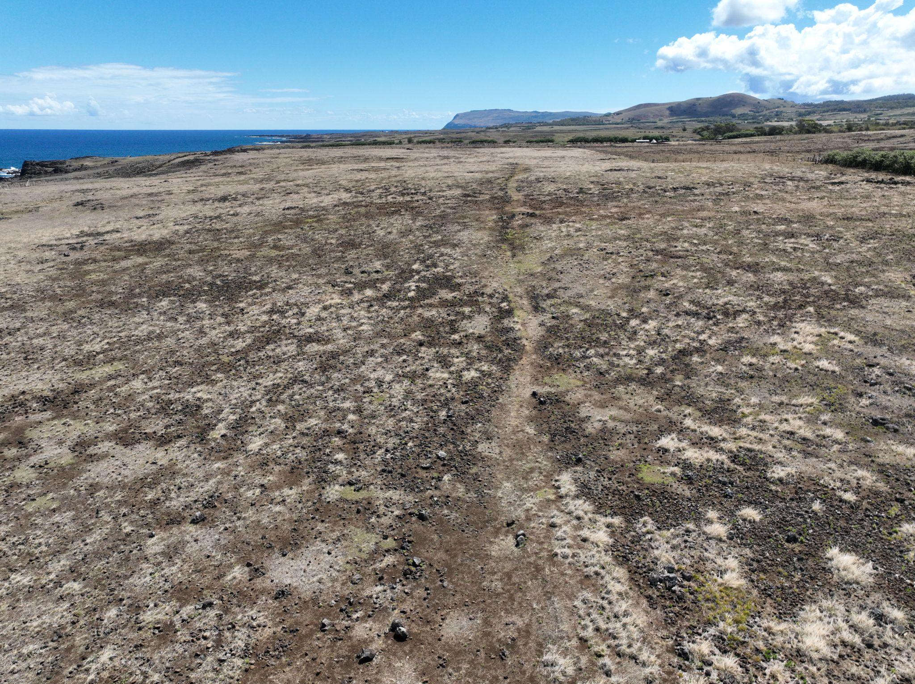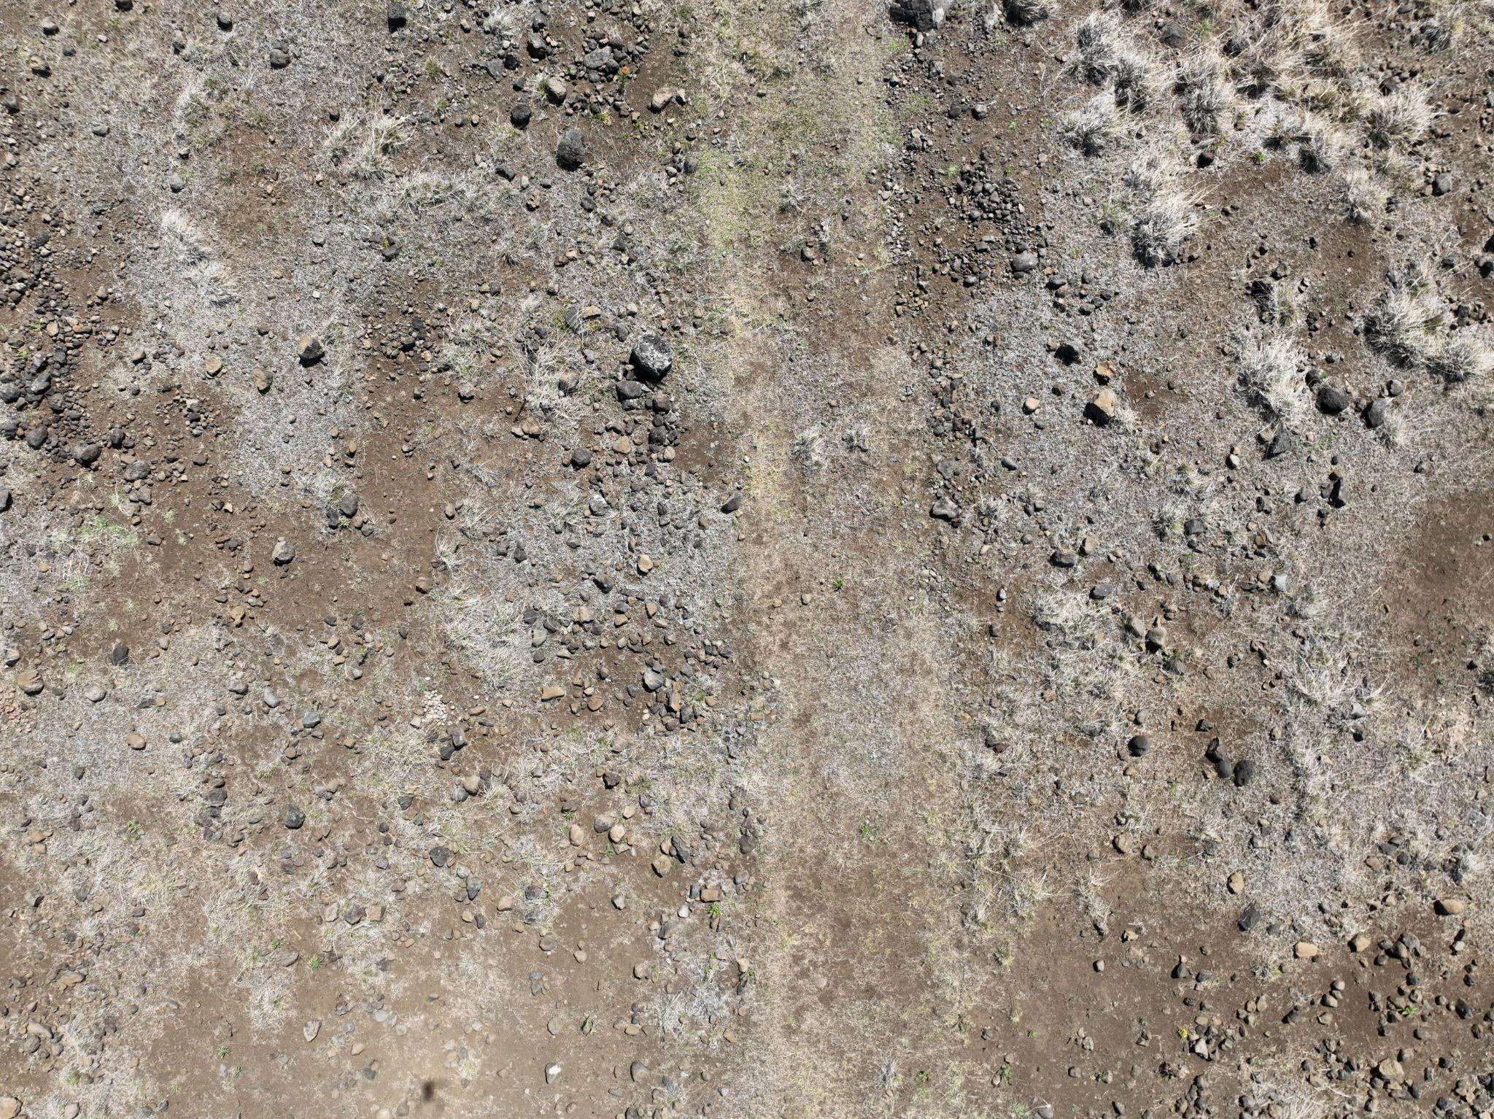

***Figure 10. Moai Roads.*** *(Left) Moai road stretching along the south coast. (Right) Detail of* moai *road. The width of the moai road is ca. 4.5 meters.*

Most significantly, the distinctive concave cross-sectional profile of these roads, consistently observed across multiple excavated segments, appears purposefully engineered rather than incidental. Rather than presenting an obstacle to upright transport, as some have suggested, this U-shaped configuration would have served as a critical control mechanism for walking *moai*. The concave profile would naturally center a rocking statue, preventing lateral drift and helping maintain directional control during the forward-rocking motion. Each step would be guided by the road's geometry, with the curved walls providing both physical constraints and visual alignment cues for the transport teams. This engineering feature transforms what might otherwise be unpredictable movement across rough terrain into a controlled, directed progression along a prepared pathway, precisely the kind of infrastructure one would expect if upright transport methods were indeed the primary means of moving *moai* across the island.

## 2.3. Alternative Transport Mechanisms

Based on an argument that the island lacked sufficient resources for making rope (addressed below), Velasco [(2019)](https://www.zotero.org/google-docs/?U6o8AD) proposed an alternative horizontal transport method that attempted to address the rope availability problem on Rapa Nui. His model suggests that *moai* were transported in a supine position on two "propulsion logs" approximately 10 meters in length and 0.35-0.50 meters in diameter. These logs, with recesses carved into their upper surfaces to support the *moai's* back, would rest perpendicular to a series of wooden rails placed like train tracks, spaced 0.5-1.0 meters apart. The system would function through teams pushing the propulsion logs forward along lubricated rails, with the *moai* remaining stable throughout transport. For uphill sections, Velasco proposed using levers positioned in the circular holes found alongside roads, arguing these served as fulcrums to multiply force.

However, this model faces several critical limitations. First, the wooden infrastructure required would demand substantial quantities of straight, durable hardwood logs. While Velasco acknowledges the use of Jubaea palm wood, the island's forest composition was dominated by palms rather than the hardwood species typically required for such heavy-duty applications. The small hardwood species identified through archaeobotanical studies (such as *Alphitonia* and *Elaeocarpus*) represented only a minor fraction of available timber and would have been insufficient for the extensive rail networks his model requires [(Orliac and Orliac, 2008)](https://www.zotero.org/google-docs/?0ZZkFc).

Moreover, Love's [(2001)](https://www.zotero.org/google-docs/?M825up) archaeological excavations revealed that *moai* roads exhibit a concave cross-section, either U or V-shaped, which would complicate the placement and stability of Velasco's proposed rail system. While Velasco suggests rails could be positioned in the lower areas of these concave paths, this configuration would create significant engineering challenges for maintaining alignment and preventing lateral slippage under multi-ton loads. Additionally, the presence of pits around the roads is explained as cultivation pits found in agricultural areas (Stevenson et al., 2006, 2007) and pre- or post-dating road use.

Most critically, this horizontal transport hypothesis cannot explain the archaeological evidence observed on the road *moai* that display consistent forward-leaning postures, dorsal wear patterns, and specific breakage configurations. These features, which serve no functional purpose in horizontal transport, remain unexplained by Velasco's model, as do the mechanisms for initial horizontal positioning of completed statues and their subsequent erection at *ahu* sites.

## 2.4. Nothing new? Building on Pavel’s Pioneering Work and the Critical Morphological Discovery

The walking hypothesis has deep roots in both Rapa Nui oral tradition and experimental archaeology. The Rapanui people have long maintained that their ancestors made the *moai* “walk” from the quarry, a claim often dismissed by Western scholars as metaphorical or mythological. Pavel Pavel, a Czech engineer, took these oral traditions seriously and, as early as 1982, began arguing for vertical transport based on both ethnographic accounts and his own engineering analysis. In 1986, Pavel conducted the first serious experimental attempt to demonstrate vertical *moai* transport, working with Thor Heyerdahl and a team of assistants to move a concrete *moai* replica in an upright position [(Heyerdahl, 1989, pp. 240–241)](https://www.zotero.org/google-docs/?Gxbges). His team successfully demonstrated that a statue could be moved upright using ropes, with the crews performing a “shuffling” or “wiggling” motion. The statue did move forward, validating the basic concept of vertical transport [(Pavel 2018, 2021)](https://www.zotero.org/google-docs/?FRoMQp).

However, Pavel’s experiments encountered significant limitations that prevented wider acceptance of the walking hypothesis. His method required substantial physical effort, achieved only limited forward progress (estimated at 100 meters per day under ideal conditions), and, most problematically, caused damage to the statue’s base through friction with the ground. Critics argued that if this method could barely move a statue a short distance without causing severe abrasion, it could never account for transporting it over kilometers of rough terrain.

Our research revealed why Pavel’s experiments, though conceptually on target, struggled practically: he used the wrong form of *moai*. Pavel’s actual *ahu moai*, like those in all subsequent experiments, including Van Tilburg’s replica, was based on the form of *moai* erected on *ahu* platforms—statues that had already been modified for permanent display. These *ahu moai* (modified to completion) stand vertically upright (bases flattened) with their center of mass positioned stably over their base, requiring significant force to tilt and producing primarily twisting motion rather than forward movement when rocked.

On road *moai,* the forward lean positions the center of mass at or slightly beyond the front edge of the base, creating inherent instability that Pavel’s upright statue lacked. When tilted laterally, this forward-displaced mass not only rocks the statue but also causes it to fall forward in a controlled manner. The rounded base edge then acts as a pivot point, allowing the statue to roll forward with each oscillation rather than simply twisting in place. Each lateral rocking motion thus produces a definite forward “step” without the grinding friction that quickly damaged the *moai* that Pavel used.

The insight on morphology explains why Pavel’s experiments failed to convince skeptics. He was trying to walk a statue specifically engineered to stand still. The modifications made to *moai* upon reaching an *ahu*—trimming the base, adjusting the lean, and creating a stable upright stance—were precisely designed for stability, not mobility. Pavel correctly identified that *moai* moved vertically, but without recognizing the specialized transport morphology of *moai*, his method appeared impractical for long-distance movement.

Our experimental validation, using an accurately proportioned Rapa Nui road *moai* replica, vindicated both the Rapa Nui oral tradition and Pavel’s vertical transport hypothesis, while revealing the sophisticated engineering that made such transport practical. Where Pavel’s upright statue required constant force and suffered base damage, our forward-leaning replica, with its curved base, walked smoothly with minimal effort, covering 100 meters in 40 minutes, compared to Pavel’s full-day estimate for the same distance.

The progression from Pavel’s pioneering work to our morphologically informed experiments underscores the need to integrate indigenous knowledge, experimental archaeology, and detailed analysis of variation in form. Pavel deserves recognition for taking oral traditions seriously and challenging the dominant assumption of horizontal transport, a move that invited ridicule from established scholars. His experiments suggested that vertical transport was feasible and consistent with cultural memory. Our contribution builds on this by showing that ancestral engineers intentionally designed statues for walking. These statues were later modified to stand erect on ceremonial platforms, a transformation that effectively erased the morphological features essential for movement. Earlier researchers had overlooked the distinction between road *moai* and *ahu moai*.

This discovery transforms our understanding of Rapanui engineering sophistication. The ancient islanders did not move statues upright merely because it was possible; they optimized their morphology for efficient transport. Features such as the forward tilt, curved base, and specific width ratios reflect deliberate adaptations for dynamic walking. Once the statues reached their destinations, these transport features were carved away to create stable, upright monuments. In retrospect, Pavel’s insight appears even more remarkable: despite working with a modified *ahu moai*, he correctly hypothesized vertical transport. What he lacked was the archaeological evidence revealing just how ingeniously the original walking statues had been engineered.

## 2.5. The "Spiritual Path" Interpretation

Richards et al. [(2011)](https://www.zotero.org/google-docs/?G7zOdr), Seager Thomas et al. [(2023)](https://www.zotero.org/google-docs/?wLBDMl), and Cauwe and De Dapper [(2022, 2015)](https://www.zotero.org/google-docs/?WCSCZx) present a speculative interpretation of the road *moai* distribution, arguing that these statues were deliberately positioned along ceremonial paths leading to the "sacred center" of Rano Raraku rather than representing transport failures. Their hypothesis rests on four primary observations: (1) the increased density of statues near the quarry, which they interpret as intentional clustering at a ritual boundary and the consistent outward-facing orientation of road *moai*, suggesting deliberate positioning; (2) geophysical evidence indicating possible platform structures beneath some statues, which they argue demonstrates permanent installation rather than abandonment; and (3) patterns of weathering of the surfaces of the road *moai*.

### 2.5.1. Spatial Positions of Road *Moai*

To evaluate the first claim quantitatively, we analyze the spatial distribution of road *moai* and consider whether the pattern is consistent with transport failures versus deliberate ceremonial placement. Transport failures in any system tend to follow predictable patterns: early failures due to defects or inexperience, ongoing random failures resulting from unpredictable events, and potential late-stage failures stemming from cumulative stress (Figure 11). For *moai* transport, each kilometer from Rano Raraku represents additional stress from lifting, rotating, and "walking" multi-ton statues across challenging terrain [(Lipo et al., 2013; Pavel, 1995)](https://www.zotero.org/google-docs/?irZaxX).

If road *moai* represent transport failures, we would expect the highest concentration of failures near the quarry, where statues with hidden flaws—such as internal cracks, zones of weak stone, or structural vulnerabilities—would likely fail under initial transport stresses. Simultaneously, transport teams would be learning and refining their techniques, with early procedural errors contributing to failures. As teams mastered the walking method and structurally sound statues continued their journey, failure rates should stabilize.

Conversely, if road *moai* were deliberately positioned as ritual markers, their distribution should reflect cultural tradition or human intentionality rather than mechanical constraints. However, simply asserting that *moai* positions are "ritual" because they appear intentional constitutes circular reasoning: we cannot define something as ritual merely by declaring it so. To make meaningful claims about ritual placement, we must first establish clear expectations about what distinguishes intentional positioning from circumstantial abandonment. In the case of *moai* distribution, this requires identifying placement attributes that result from human activity rather than natural or mechanical processes [(Dunnell, 1971)](https://www.zotero.org/google-docs/?zG6Ad3).

While an argument for *moai* as ritual markers may seem intuitively pleasing to account for those near the quarry, it raises critical questions about classification and interpretation. Are statues found at great distances and entirely out-of-view of the quarry also ritual installations? Where do ritually placed *moai* end and transport failures begin? How would we know? These questions highlight the fundamental challenge of distinguishing between intentional ritual placement and mechanical abandonment without falling into circular logic.

To answer these questions rigorously, we would need to demonstrate positioning characteristics that cannot be adequately explained by transport failure, topographic constraints, or other mechanical factors; characteristics such as consistent orientations, regular spacing intervals, or systematic relationships to other cultural features that transcend the practicalities of moving multi-ton statues across challenging terrain. The ritual hypothesis must therefore first falsify the null hypothesis that these locations are "natural" outcomes of mechanical failure in the same way that flake scars on lithics are identified as artificial only after determining they cannot be explained by any known natural phenomenon [(Barnes, 1939; Peacock, 1991)](https://www.zotero.org/google-docs/?L8gacq). Thus, we must first evaluate the "natural" expectations for *moai* distributions before we can identify deviations that might signal ritual intent.

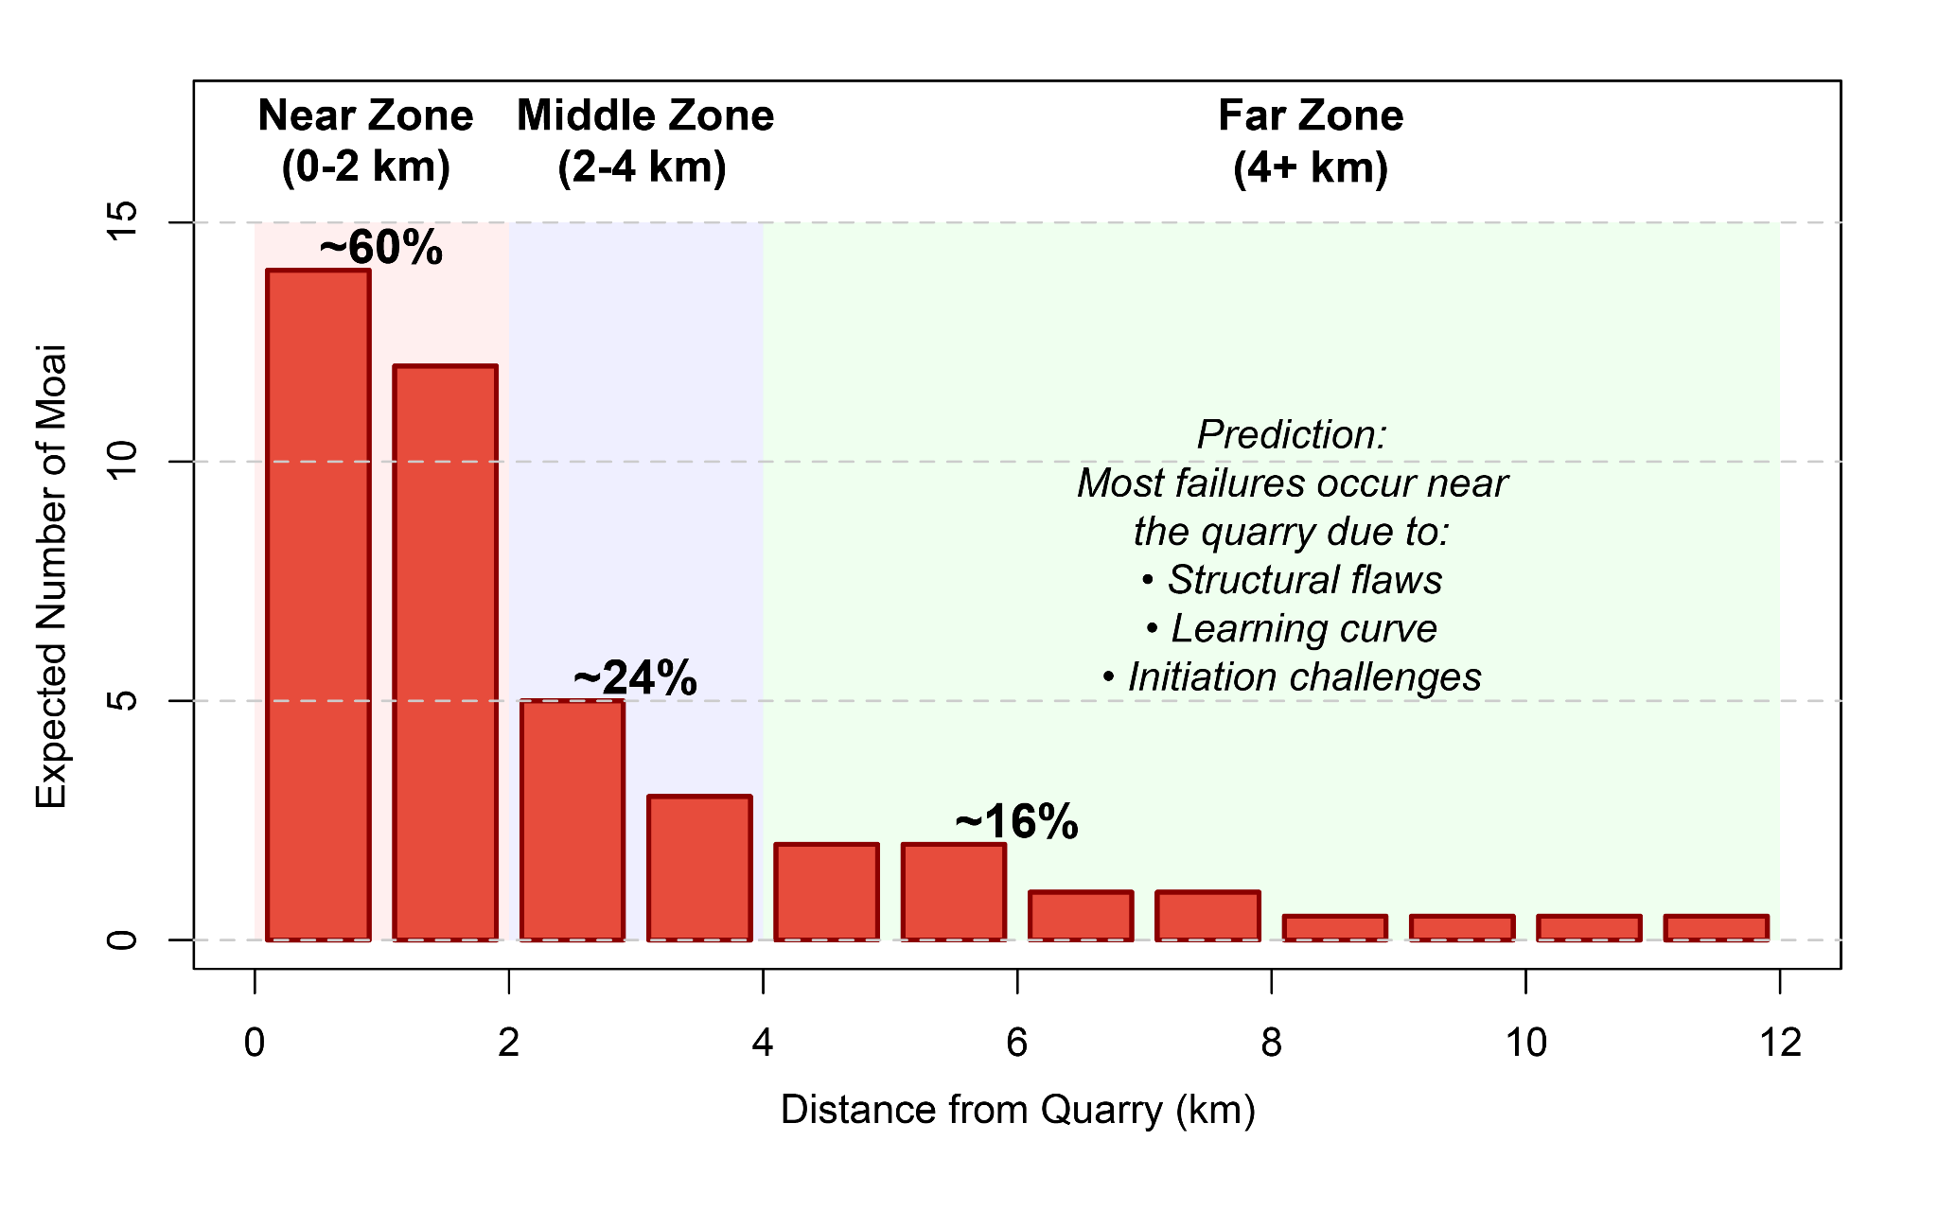

***Figure 11. Expected distribution of road moai under the transport failure hypothesis.*** *The histogram shows the predicted spatial pattern if* moai *locations represent transport failures, with extreme concentration near the quarry where initial challenges (structural flaws, inexperienced teams, and initiation of movement) would cause most failures. The model predicts approximately 60% of failures within 2 km, 24% between 2-4 km, and 16% beyond 4 km. Background shading indicates distance zones: Near (0-2 km, red), Middle (2-4 km, blue), and Far (4+ km, green).*

Our analysis of 62 road *moai* reveals patterns strongly suggestive of transport failure (Figure 12). The most striking finding is the extreme concentration near the quarry: the cumulative distribution function indicates that 50% of failures occur within 1.79 km of Rano Raraku, with 51.6% concentrated in the first 2 km—a concentration that exceeds uniform distribution expectations by a factor of 3.5 (p < 0.001). This extreme clustering near the point of origin is consistent with a failure process rather than intentional distribution.

The failure density analysis reveals that the number of road *moai* per kilometer is highest in the first 2 km from the quarry and decreases dramatically with distance (Figure 12). Among the 62 documented road *moai*, failures are not randomly distributed along the transport routes but show extreme concentration near the point of origin. This pattern is consistent with a process where initial transport attempts faced the highest risk of failure, whether from structural or morphological flaws in the *moai*, inexperience with transport techniques, or the particular challenges of initiating movement.

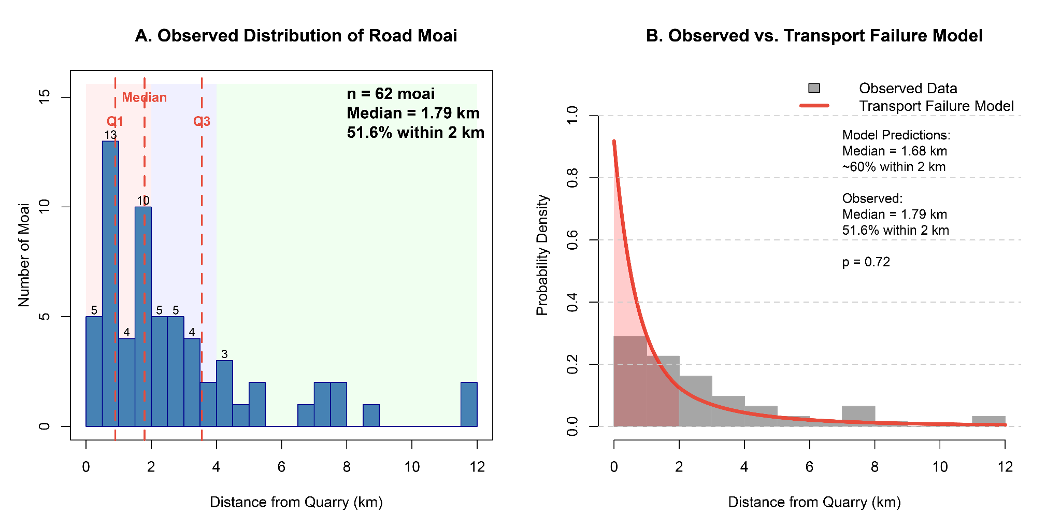

***Figure 12. Observed road moai distribution and statistical comparison with transport failure expectations****. (A) Histogram showing extreme concentration of 62 road moai near the quarry, with 51.6% within 2 km. Quartile markers indicate 25%, 50% (median = 1.79 km), and 75% of the distribution. (B) Comparison of observed distribution (gray bars) with transport failure model prediction (red line). The high p-value (p = 0.72) indicates no significant difference between the observed median distance and the transport failure model prediction, confirming the close visual alignment. In contrast, ceremonial placement models are firmly rejected (p < 0.001), supporting the interpretation that road moai represent transport failures rather than deliberate ceremonial placements.*

The transport failure hypothesis also generates predictions about the relationship between statue size and failure location. The physics of "walking" a statue depends on maintaining precise balance points, controlling momentum, and managing rotational forces, all of which scale non-linearly with size [(Lipo et al., 2013; Pavel, 1995)](https://www.zotero.org/google-docs/?dcws4q). The gravitational torque attempting to topple a forward-leaning statue increases with both height and mass, following the relationship *τ = mgh sin(θ)*, where *m* is mass, *h* is the height of the center of gravity, and *θ* is the tilt angle. Larger statues not only weigh more but are taller and have higher centers of gravity, creating a compound effect where doubling statue height can quadruple the toppling forces that transport teams must control [(Hunt and Lipo, 2011)](https://www.zotero.org/google-docs/?ELIEYQ).

This mechanical reality generates a testable prediction: if road *moai* represent transport failures, we should observe a negative correlation between statue size and transport distance, with larger statues disproportionately failing near the quarry. Conversely, if road *moai* represent ceremonial placements, size might correlate positively with distance (important statues placed at significant locations) or show no relationship (size reflecting status rather than transport constraints).

Our analysis of 38 road *moai* with complete measurements reveals patterns consistent with mechanical constraints. The scatter plot shows a negative correlation between statue size and transport distance (Spearman's ρ = -0.24, p = 0.157), indicating that larger statues tended to fail earlier in the transport process. Mean statue lengths show a clear decreasing trend: near-quarry failures (0-2 km) average 637 ± 160 cm, middle-distance failures (2-4 km) average 626 ± 201 cm, and far-distance failures (>4 km) average 569 ± 203 cm—a 10.7% decrease in mean size.

Particularly revealing are the extreme cases. Of the six statues exceeding 8 m in length, three (50%) failed within 1.5 km of the quarry, while the others reached only 1.64, 2.17, and 4.11 km; none achieved distances greater than 4.5 km, despite approximately 15% of all road *moai* reaching such distances. This suggests a *de facto* size limit for successful long-distance transport, consistent with engineering constraints rather than ceremonial planning (Figure 13).

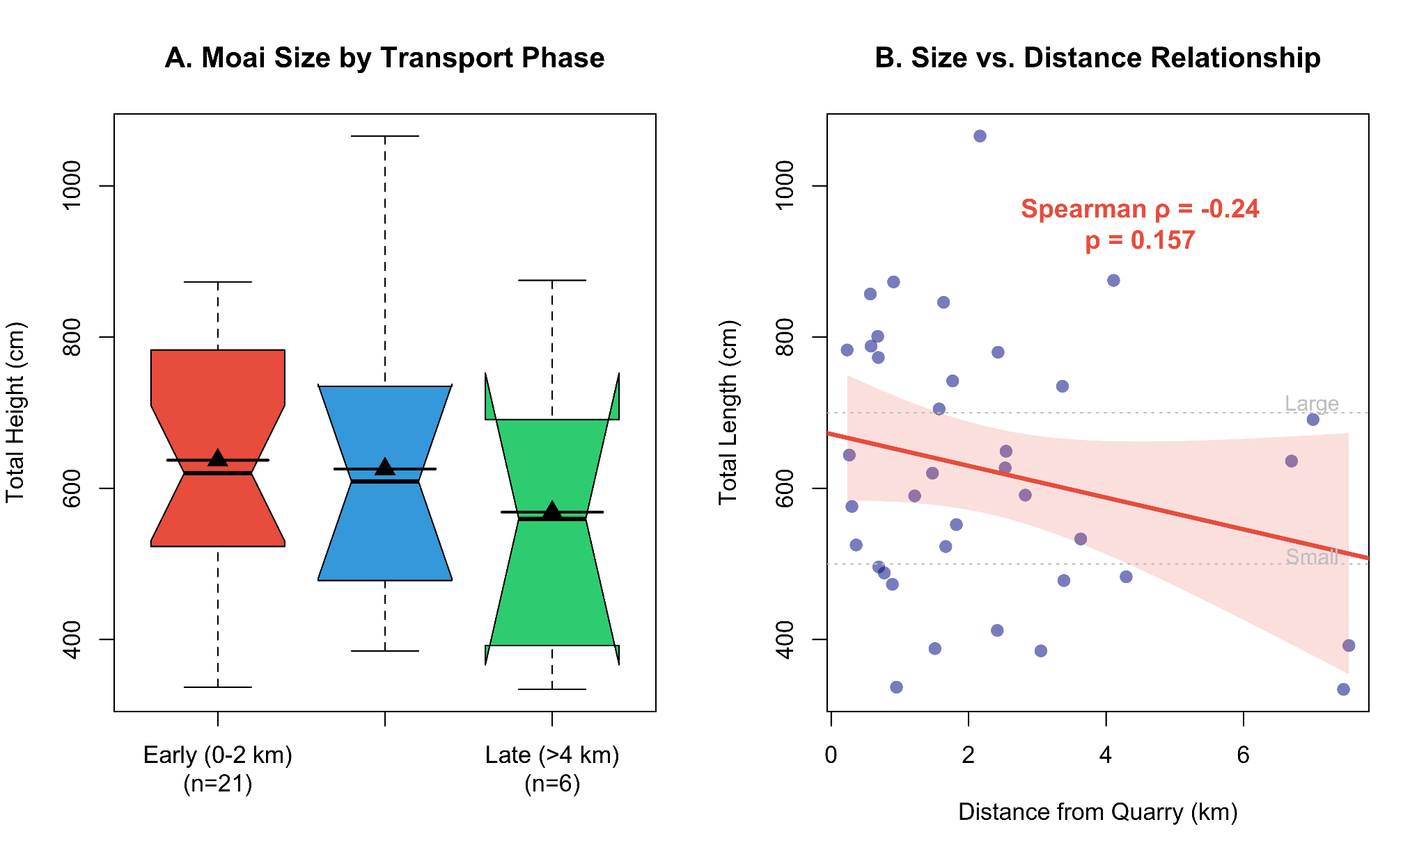

***Figure 13. Analysis of moai size in relation to transport distance.*** *(A) Box plots showing size distributions across transport phases, with median values decreasing from early to late phases. (B) Scatter plot with regression line demonstrating a negative correlation between statue size and distance from the quarry. The shaded area represents 95% confidence intervals for the regression.*

The ceremonial placement hypothesis can be re-evaluated through this spatial analysis. The concentration of statues near the quarry peaks sharply and decreases smoothly, rather than following the step function expected at a discrete ceremonial threshold [(Richards et al., 2011)](https://www.zotero.org/google-docs/?wGdRbw). The outward-facing orientations align with the vertical walking transport mechanics, where forward-leaning statues would naturally fall in the direction of their travel when control was lost [(Lipo et al., 2013)](https://www.zotero.org/google-docs/?umHCa4).

### 2.5.2. Evidence for Platforms

An additional line of evidence argued to reveal a relationship between the placement of road *moai* and a broader ritual landscape is the discovery of at least one stone platform during excavations conducted by Skjølsvold as part of the 1955 Heyerdahl expedition (Skjølsvold, 1961). Although the original interpretation linked these features to transport functions, Heyerdahl (1989: 56) later proposed that they may support Routledge’s (1919: 193) earlier hypothesis that *moai* were positioned upright along a ceremonial pathway leading to the quarry. Richards et al. (2011: 204), drawing on resistivity survey data collected by Croucher (2010), argue that other *moai* may also rest on similar platforms. However, the geophysical data are inconclusive, as comparable high-resistivity values occur in areas without visible structural remains, raising the possibility that such anomalies reflect natural variation rather than cultural features. Moreover, the presence of platforms does not falsify the walking hypothesis. These features likely represent temporary supports used during transport pauses; evidence for ongoing transport rather than permanent installation.

### 2.5.3. Weathering Pattern Arguments

Similar to notions of ritual statue placement, Cauwe and De Dapper [(2015, p. 16)](https://www.zotero.org/google-docs/?VDHIAY) hypothesize that “isolated” *moai* were not in transit nor abandoned, but rather the result of voluntary acts, not failed transport. They speculate that the *moai* stood for perhaps centuries before being carefully laid down. Cauwe and De Dapper make several questionable assumptions, including that *moai* falling from a vertical position would always break and that at least some of these road *moai* were observed standing in the 18th century. Other aspects of their argument rely on imaginative speculations not subject to testing or falsification. As a central part of their argument, Cauwe and De Dapper contend that vertical weathering patterns ("runnels") on prone *moai* indicate extended standing periods before deliberate horizontal placement. They argue these patterns formed primarily from rainfall running down standing statues. Their argument follows earlier speculations made by Routledge [(Routledge, 1919, p. 195)](https://www.zotero.org/google-docs/?vy2hrK).

This interpretation of erosion overlooks crucial geological factors and archaeological observations. *Moai* were carved with hyalotuff bedding planes of the volcanic tuff, which were commonly aligned along the statue's long axis, to minimize the risk of breakage, as fractures tend to follow bedding planes. Since weathering in hyalotuff occurs predominantly in clay-rich bands that swell with moisture absorption [(Wedekind et al., 2013)](https://www.zotero.org/google-docs/?bFTKkh), vertical runnels reflect the original bedding orientation, regardless of the transport method or subsequent positioning.

Furthermore, protected surfaces on prone statues, including chest, face, belly, lack runnels, and preserve fine carved details such as hands (Figure 14). These differential weathering patterns indicate post-fall erosion of exposed surfaces rather than pre-placement weathering. Additionally, the statue bases show erosion levels comparable to those of the upper surfaces, suggesting that weathering occurred primarily after the statues fell rather than during extended standing periods.

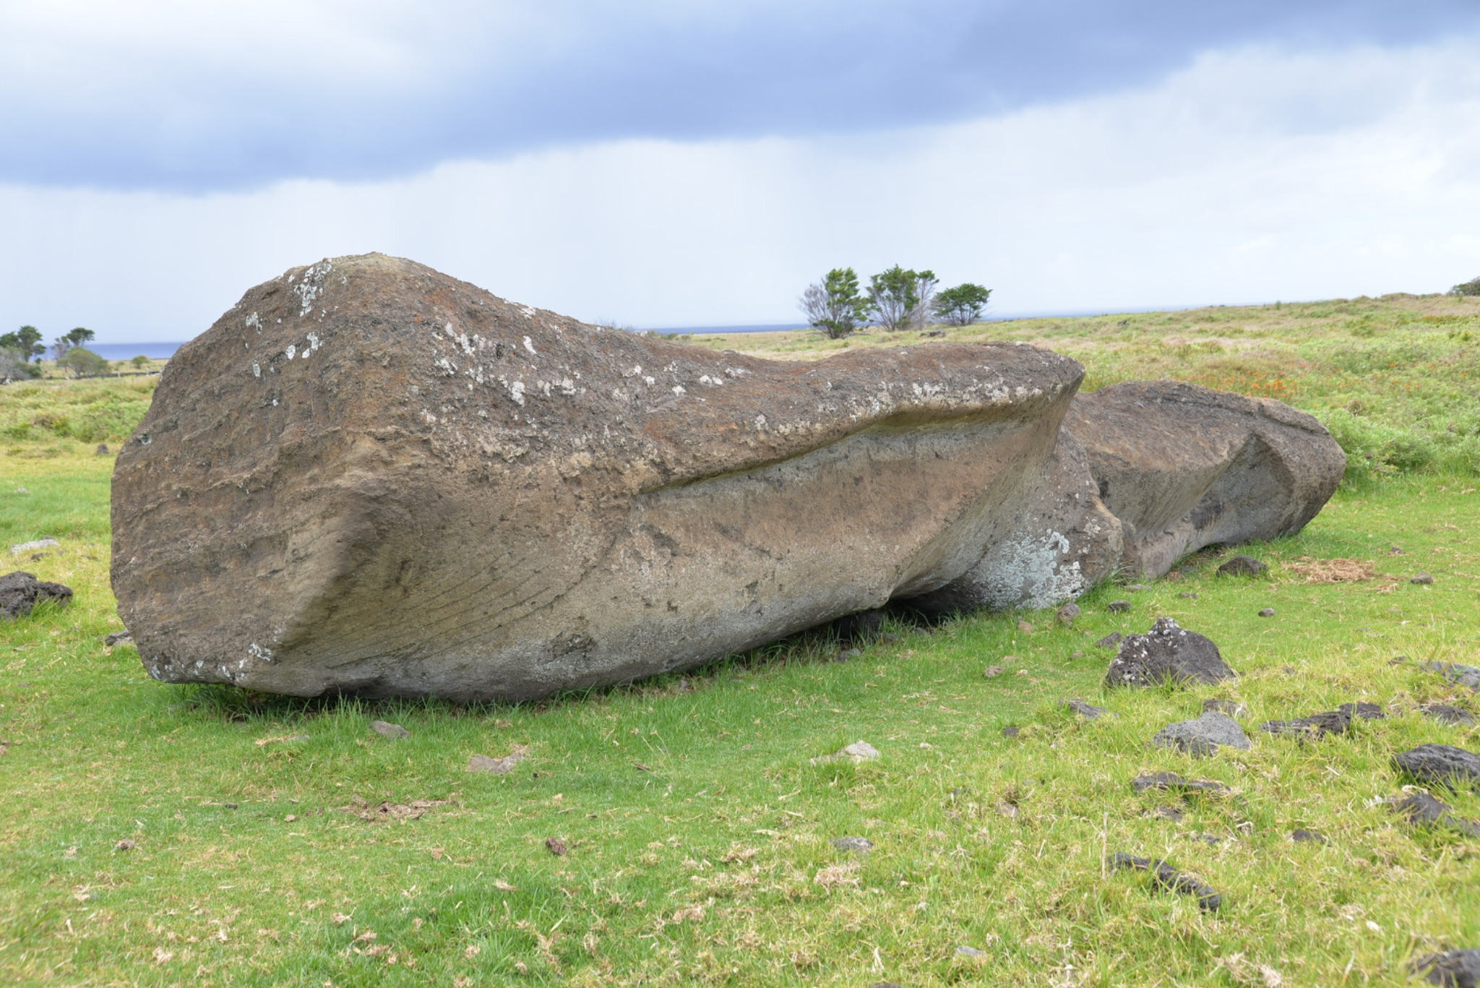

***Figure 14. Road moai with erosion runnels on exposed surfaces, back, and base.*** *The protected surfaces are well preserved. If erosion had occurred over long periods while the moai stood, we would expect equal weathering of the front surfaces, which is not evident (note the smooth front and details such as the hand and nipple). Also, note the horizontal bedding at the base of the moai. Horizontal erosion occurs along bedding planes due to varying degrees of consolidation, rather than from the direction of rainwater runoff.*

The assumption that unbroken road *moai* were “carefully laid down” rather than fallen ignores both material properties and archaeological context. While bedding alignment reduced breakage probability, it did not guarantee fracture upon falling. Moreover, architectural features beneath or around *moai* cannot be assumed to be contemporary with the placement of the statues, as post-transport modifications, including burials and semi-pyramidal *ahu* construction, are well-documented throughout Rapa Nui [(Martinsson-Wallin, 1994)](https://www.zotero.org/google-docs/?t3g7dA).

The position and form of the *moai* do not provide evidence of a sacred landscape of ritual markers, but rather a record of prehistoric engineering, complete with the learning process and occasional failures that characterize human technological endeavors. The spatial patterns preserved along these ancient paths reveal a history of innovation, perseverance, and ultimate success in one of the ancient world's most ambitious transport projects.

## 2.7. Rope?

A key requirement for the “walking” hypothesis is that the rope is sufficiently strong that it could be used to rock the *moai* from side to side. Rope materials were available, and the islanders made ropes for fishing and other household activities (Figure 15). In 1830, Waldegrave [(cited in Fischer, 1993, p. 67)](https://www.zotero.org/google-docs/?YBAUWD) visited the island on the *HMS Seringapatam* and notes: “They had fine lines made from vegetable fibre, exceedingly well-twisted, and nets of very neat workmanship.*”*  Thomson [(1891, p. 460)](https://www.zotero.org/google-docs/?IxJlUj) notes that “The coarse nets and cordage was made from the twisted bark of the *hibiscus*, and the fine ones from the fiber of the indigenous hemp. From the strong heavy ropes used in raising and transporting the colossal images to the light but durable fish-lines, the threads were all twisted by hand, across the knee, into even strands, which were multiplied according to the size and strength required.”

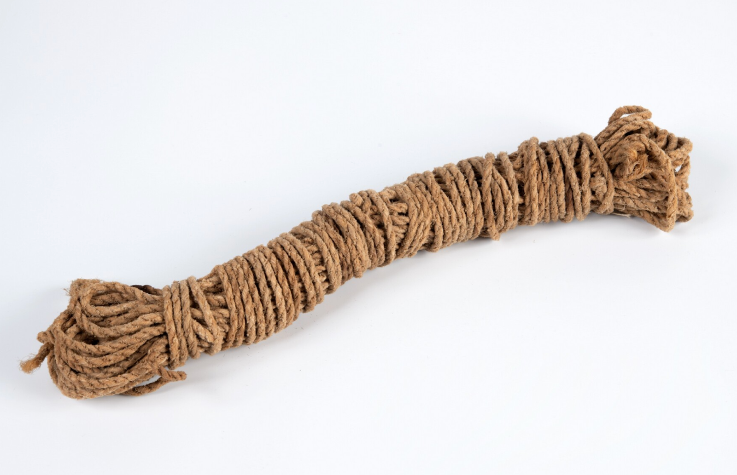

***Figure 15. Example of Rapa Nui rope at the Museum Volkenkunde, Leiden.*** *RV-517-13. This work is licensed under a* [*Creative Commons Attribution-ShareAlike 4.0 International License*](http://creativecommons.org/licenses/by-sa/4.0/)*.*

Among the plants that provided strong fibers for cordage was *hauhau* (*Triumfetta semitroba*), a shrub found on Rapa Nui and across the Pacific Islands [(Métraux, 1940, p. 17)](https://www.zotero.org/google-docs/?68vR6a). In addition, cordage was made from *mahute*, which is bark from the paper mulberry tree (*Broussonetia papyrifera*), a small deciduous tree native to East Asia. It was widely cultivated and intentionally spread throughout Polynesia, including Rapa Nui, by early Polynesian voyagers. Both plants were capable of making sturdy cords and ropes. Fine, sturdy cordage and rope are known throughout Polynesia [(e.g., Buck, 1957)](https://www.zotero.org/google-docs/?ubLgg3).

Researcher Maureen Folk [(2018)](https://www.zotero.org/google-docs/?KeBupx) examined the “walking with ropes” scenario from an environmental and materials perspective. Her study modeled the amount of cordage needed to move *moai* upright and the implications for Rapa Nui’s wood resources. Her findings were striking: each statue transported would require roughly three 30-meter ropes, which would consume fiber from an estimated ninelarge shrubs or small trees, if made using a traditional two-ply twisting method. If a stronger, thicker “composite” rope technique were used, the material required would be about 15–16 shrubs' worth of fiber per statue. Folk then scaled these experiments up. Based on her estimates, moving more than 400 *moai* found outside the quarry with new ropes each time could theoretically consume 6,400 trees worth of fibrous plants. However, since *moai* appear to have been transported across the island for over 500 years, the annual use of shrubs such as *hauhau* would have been well within their capacity to regrow.

### *2.7.1. Hauhau* and Deforestation?

Collapse proponents have long assumed that the loss of palm forests also resulted in habitat destruction, and thus the loss of *hauhau* to make rope. Diamond [(2005, p. 68)](https://www.zotero.org/google-docs/?IlC5ek) writes that as deforestation progressed, *“*the islanders ran out of timber and rope to transport and erect their statues.*”* Diamond’s ecocide narrative suggests that without wood for rollers or strong ropes, statues “walking” (or any other form of transport) became impossible. Flenley and Bahn [(2003, p. 164)](https://www.zotero.org/google-docs/?uaN1I7) argue thattheir pollen data indicate a dominance of *hauhau* in the earliest (pre-human colonization) layers, but later in the sequence, all trees decline, with nearly complete forest clearance evident in the later layers. Thus, the implication is that once the islanders had no large trees or sufficient fiber plants left, they could not obtain the ropes to transport the multi-ton statues. Velasco [(2019)](https://www.zotero.org/google-docs/?UK67FV) makes a similar argument and uses a presumed lack of material for ropes as the basis of his “rowing” method as previously described.

### 2.7.2. Was *hauhau* unavailable to islanders for rope and cordage making?

Unlike the towering palms that once covered the island, *hauhau* was a shrubby pioneer plant, well-suited to disturbed landscapes ([https://dev.floranorthamerica.org/Triumfetta_semitriloba?utm](https://dev.floranorthamerica.org/Triumfetta_semitriloba?utm_source=chatgpt.com)). It thrived in areas where the soil had been recently turned, whether by natural forces or human activity. Rapa Nui, especially during rapid environmental transformation, would have been an ideal habitat for its growth and expansion. As the palm forests were gradually cleared to make way for cultivation, the conditions became increasingly favorable for *hauhau* to thrive. While other plants may have struggled in the island’s changing landscape, *hauhau* would have spread, ensuring that a steady supply of fibrous material remained available for making essential rope. *Hauhau* never completely disappeared from the island. It grows on Rapa Nui today, and there is no evidence that it was reintroduced from another island. Thus, it is unlikely that *Triumfetta* was ever eliminated or reduced to the point of precluding rope production in ancient times.

# 3. Conclusion

The walking moai hypothesis offers a comprehensive explanation of the archaeological evidence, including distinctive statue morphology, road characteristics, breakage patterns, spatial distributions, and weathering features. Experimental replications have demonstrated the feasibility and efficiency of vertical transport, with small teams moving large statues using resources available to ancient Rapa Nui.

When examined systematically, the converging lines of evidence for vertical transport are particularly compelling. The distribution of fallen moai, their consistent breakage patterns, and deliberate morphological features, including forward lean and carefully calibrated center of mass, cannot be accounted for by alternative transport models. The physics of upright movement clarifies the forces involved, while experimental trials confirm the dynamic yet controlled nature of the process. No other hypothesis integrates these factors into a coherent explanatory framework.

Critics have yet to offer plausible alternatives that account for the full range of evidence. Appeals to intuition, selective observations, or misreadings of weathering patterns fall short in explaining the archaeological record. The predictable distribution of road *moai*, the engineering of statue morphology for walking, and successful experimental replication all point to the same conclusion. Until competing models can account for this body of evidence, the walking hypothesis remains the most robust explanation for one of Polynesia’s most remarkable engineering achievements.

The success of *moai* transport reveals a sophisticated understanding of physics and engineering among the ancient Rapa Nui islanders. Rather than requiring massive labor forces and environmental destruction, statue transport employed elegant mechanical principles, achieved through careful observation and innovative problem-solving—a testament to Polynesian ingenuity that “walked” into history.

# Data Availability

All data and R code necessary for generating the data figures (2,3,5,11,12, and 13) are available at <https://github.com/clipo/moai_walking>. The code for Figure 4 can be found at <https://github.com/clipo/hotuiti>

# References

[Alexander, R.M., 2003. Principles of Animal Locomotion. Princeton University Press, Princeton, N.J.](https://www.zotero.org/google-docs/?sAjFxL)

[Barnes, A.S., 1939. The Differences Between Natural and Human Flaking on Prehistoric Flint Implements. Am. Anthropol. 41, 99–112. https://doi.org/10.1525/aa.1939.41.1.02a00080](https://www.zotero.org/google-docs/?sAjFxL)

[Buck, P.H., 1957. Arts and crafts of Hawaii. Bishop Museum Press, Honolulu, HI.](https://www.zotero.org/google-docs/?sAjFxL)

[Callaway, E., 2012. Easter Island statues “walked” out of quarry. Nature. https://doi.org/10.1038/nature.2012.11613](https://www.zotero.org/google-docs/?sAjFxL)

[Cauwe, N., De Dapper, M., 2022. Undelivered Moai or Unidentified Monument?, in: Rull, V., Stevenson, C. (Eds.), The Prehistory of Rapa Nui (Easter Island): Towards an Integrative Interdisciplinary Framework. Springer, New York, pp. 205–235.](https://www.zotero.org/google-docs/?sAjFxL)

[Cauwe, N., De Dapper, M., 2015. The Road of the Moai, an Interrupted Travelator?, in: Easter Island: Collapse or Transformation? A State of the Art. Royal Academy for Overseas Sciences, Brussels, pp. 9–57.](https://www.zotero.org/google-docs/?sAjFxL)

[Chaffin, D.B., Andersson, G.B., Martin, B.J., 2006. Occupational Biomechanics, 4th ed. Wiley, New York.](https://www.zotero.org/google-docs/?sAjFxL)

[Diamond, J., 2011. The myths of Easter Island – Jared Diamond responds. Mark Lynas Environ. News Comment. URL https://web.archive.org/web/20190215100417/http://www.marklynas.org/2011/09/the-myths-of-easter-island-jared-diamond-responds/ (accessed 7.22.25).](https://www.zotero.org/google-docs/?sAjFxL)

[Diamond, J., 2005. Collapse: How Societies Choose to Fail or Succeed. Viking, New York.](https://www.zotero.org/google-docs/?sAjFxL)

[Dunnell, R.C., 1971. Systematics in Prehistory. The Free Press, New York.](https://www.zotero.org/google-docs/?sAjFxL)

[Fischer, S.R., 1993. The calling of H.M.S. Seringapatam at Rapanui (Easter Island) on 6 March 1830. Pac. Stud. 16, 67–84.](https://www.zotero.org/google-docs/?sAjFxL)

[Flenley, J.R., Bahn, P., 2003. The Enigmas of Easter Island. Oxford University Press, Oxford.](https://www.zotero.org/google-docs/?sAjFxL)

[Folk, M., 2018. Evaluating the Environmental and Material Implications of Moai Transport Methods on Rapa Nui. University of California, Berkeley.](https://www.zotero.org/google-docs/?sAjFxL)

[French, A.P., 1971. Vibrations and Waves. Norton, New York.](https://www.zotero.org/google-docs/?sAjFxL)

[Gioncada, A., González-Ferran, O., Lezzerini, M., Mazzuoli, R., Bisson, M., Rapu, S.A., 2010. The volcanic rocks of Easter Island (Chile) and their use for the Moai sculptures. Eur. J. Mineral. 22, 855–867.](https://www.zotero.org/google-docs/?sAjFxL)

[Heyerdahl, T., 1989. Easter Island--the mystery solved. Souvenir Press, London.](https://www.zotero.org/google-docs/?sAjFxL)

[Hibbeler, R.C., 2016. Engineering Mechanics: Dynamics, 14th ed. Pearson, London.](https://www.zotero.org/google-docs/?sAjFxL)

[Hochstetter, F.T., Haoa, S.R., Lipo, C.P., Hunt, T.L., 2011. A Public Database of Archaeological Resources on Easter Island (Rapa Nui) Using Google Earth. Lat. Am. Antiq. 22, 385–397. https://doi.org/10.7183/1045-6635.22.3.385](https://www.zotero.org/google-docs/?sAjFxL)

[Hunt, T.L., Lipo, C.P., 2011. The Statues that Walked: Unraveling the Mystery of Easter Island. Free Press, New York.](https://www.zotero.org/google-docs/?sAjFxL)

[Kuhn, T.S., 1962. The Structure of Scientific Revolutions. University of Chicago Press, Chicago.](https://www.zotero.org/google-docs/?sAjFxL)

[Laplace, P.S., 1902. A Philosophical Essay on Probabilities. John Wiley & Sons, New York.](https://www.zotero.org/google-docs/?sAjFxL)

[Lipo, C.P., Hunt, T.L., 2005. Mapping prehistoric statue roads on Easter Island. Antiquity 79, 158–168. https://doi.org/10.1017/S0003598X00113778](https://www.zotero.org/google-docs/?sAjFxL)

[Lipo, C.P., Hunt, T.L., Haoa, S.R., 2013. The “walking” megalithic statues (moai) of Easter Island. J. Archaeol. Sci. 40, 2859–2866.](https://www.zotero.org/google-docs/?sAjFxL)

[Love, C., 2001. Excavations on Moai Roads, Easter Island. Easter Island Foundation, Los Osos, California.](https://www.zotero.org/google-docs/?sAjFxL)

[Love, C.M., 2001. The Easter Island Moai Roads: Excavation Project to Investigate the roads along which the Easter Islanders over their gigantic ancestral statues (Unpublished Report). Museo Antropológico Padre Sebastián Englert, Hanga Roa, Easter Island.](https://www.zotero.org/google-docs/?sAjFxL)

[Martinsson-Wallin, H., 1994. Ahu - The Ceremonial Stone Structures of Easter Island: Analyses of Variation and Interpretation of Meanings. Uppsala University, Uppsala.](https://www.zotero.org/google-docs/?sAjFxL)

[McArdle, W.D., Katch, F.I., Katch, V.L., 2015. Exercise Physiology: Nutrition, Energy, and Human Performance, 8th ed. Wolters Kluwer, Philadelphia.](https://www.zotero.org/google-docs/?sAjFxL)

[McCall, G., 1994. Rapanui: Tradition and Survival on Easter Island, 2nd ed. University of Hawaii Press, Honolulu.](https://www.zotero.org/google-docs/?sAjFxL)

[Métraux, A., 1940. Ethnology of Easter Island. Bernice P. Bishop Museum Bulletin 160, Honolulu.](https://www.zotero.org/google-docs/?sAjFxL)

[Orliac, C., Orliac, M., 2008. Extinct flora of Easter Island, in: Di Piazza, A., Pearthree, E., Sand, C. (Eds.), At the Heart of Ancient Societies: French Contributions to Pacific Archaeology. Département Archéologie, Nouméa, New Caledonia, pp. 197–209.](https://www.zotero.org/google-docs/?sAjFxL)

[Pavel, P., 2021. Rapa Nui: 40 years of grappling with the mysteries of Easter Island. Rapa Nui Press, Easter Island.](https://www.zotero.org/google-docs/?sAjFxL)

[Pavel, P., 2018. Rapa Nui: The man who made the statues walk. VN Publishing, vel.](https://www.zotero.org/google-docs/?sAjFxL)

[Pavel, P., 1995. Reconstruction of the transport of moai, in: Fischer, S.R. (Ed.), Easter Island Studies. Oxbow Books, Oxford, pp. 141–144.](https://www.zotero.org/google-docs/?sAjFxL)

[Peacock, E., 1991. Distinguishing between Artifacts and Geofacts: A Test Case from Eastern England. J. Field Archaeol. 18, 345–361. https://doi.org/10.1179/009346991791548645](https://www.zotero.org/google-docs/?sAjFxL)

[Popper, K., 1962. Conjectures and Refutations: The Growth of Scientific Knowledge. Basic Books, New York.](https://www.zotero.org/google-docs/?sAjFxL)

[Richards, C., Croucher, K., Paoa, T., Parish, T., Tucki, E., Welham, K., 2011. Road my body goes: Re-creating ancestors from stone at the great moai quarry of Rano Raraku, Rapa Nui (Easter Island). World Archaeol. 43, 191–210.](https://www.zotero.org/google-docs/?sAjFxL)

[Routledge, K., 1919. The mystery of Easter Island: The story of an expedition. Sifton, Praed & Co, London.](https://www.zotero.org/google-docs/?sAjFxL)

[Ruina, A., Pratap, R., 2015. Introduction to Statics and Dynamics. Oxford University Press, Oxford.](https://www.zotero.org/google-docs/?sAjFxL)

[Schumacher, Z., 2013. A geo-spatial database of the monumental statuary (moaj) of Easter Island, Chile (MA Thesis). California State University, Long Beach, Long Beach.](https://www.zotero.org/google-docs/?sAjFxL)

[Seager Thomas, M., Hamilton, S., Armstrong, F., 2023. Were the Moai Along Rapa Nui’s Ara Moai (Moai Roads) Standing? The LOC “Moai Roads” Survey, 2010–2017. UCL Rapa Nui Landscapes of Construction Interim Reports, 17 (LOC17) (Unpublished Report). University College London, London. https://doi.org/10.13140/RG.2.2.12068.24968/1](https://www.zotero.org/google-docs/?sAjFxL)

[Taylor, J.R., 2005. Classical Mechanics. University Science Books, Sausalito, CA.](https://www.zotero.org/google-docs/?sAjFxL)

[Thomson, W.J., 1891. Te Pito te Henua or Easter Island. Smithsonian Institution, Washington, D.C.](https://www.zotero.org/google-docs/?sAjFxL)

[Van Tilburg, J.A., 2012. Walking moai and “Levitated Mass.” Easter Isl. Statue Proj. URL https://www.eisp.org/4595/ (accessed 7.5.25).](https://www.zotero.org/google-docs/?sAjFxL)

[Van Tilburg, J.A., 1994. Easter Island: Archaeology, Ecology, and Culture. Smithsonian Institution Press, Washington.](https://www.zotero.org/google-docs/?sAjFxL)

[Van Tilburg, J.A., 1986. Power and Symbol: The Stylistic Analysis of Easter Island Monolithic Sculpture, PhD dissertation, University of California, Los Angeles.](https://www.zotero.org/google-docs/?sAjFxL)

[Velasco, G., 2019. Moving the Moai - A New Theoretical Model, in: Vogt, B., Kühlem, A., Mieth, A., Bork, H.-R. (Eds.), Easter Island and the Pacific: Cultural and Environmental Dynamics. Rapa Nui Press, Easter Island, pp. 301–310.](https://www.zotero.org/google-docs/?sAjFxL)

[Wedekind, W., Zink, A., Barthel, S., 2013. Petrographical characterization of Easter Island statue rock. Archaeometry 55, 564–578. https://doi.org/10.1111/j.1475-4754.2012.00694.x](https://www.zotero.org/google-docs/?sAjFxL)